2024 - Market consultation 68 – Increase of Long-Term Slot Capacity
Consultation as from 2nd of April 2024 to 23rd of April 2024
In an ongoing endeavour to further secure the energy supply of Belgium and North-West Europe on the long-term, Fluxys LNG is currently reviewing its service offer. This market consultation mainly targets the expansion of long-term capacity at the Zeebrugge LNG Terminal, while also integrating incentives to effectively mitigate potential 'threat to heel' concerns.
In response to market demand and feedback, Fluxys LNG has spent the last couple of years integrating additional short-term slots with its existing long-term capacity without altering the performance of the service.
The recent Call for Market Interest (CMI) at the Zeebrugge LNG terminal has shown a strong interest in both slots and regasification capacities over the long-term. In the light of this demand and its willingness to increase the security of supply, Fluxys LNG is pleased to announce the replacement of its current short-term offering of additional capacity by a long-term offer, as from April 2027. This offer will consist of 2 lots of 12 slots per year.

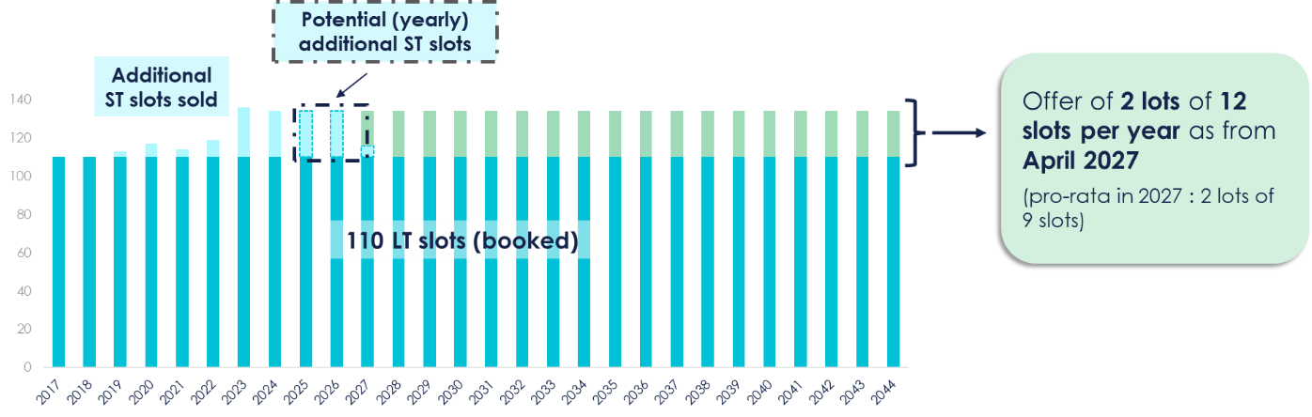
Fluxys LNG therefore proposes the following amendments to the regulatory documents:

LNG Terminalling Programme
  - The yearly number of slots is increased from 110 to 134 slots as from April 2027, with a pro rata in 2027 leading to 128 slots.
  - Small technical updates are added following the recent commissioning of the Open Rack Vaporizers.

LNG Terminalling Access Code
  - Include the possibility to offer LNG services in lots to the market.
  - Include the start date of the LNG services as a differentiating factor for the allocation.
  - By combining the subscription window with an auction window, Fluxys LNG establishes a final and additional step for allocation when full allocation among competing participants cannot be achieved. This ensures a robust mechanism for allocation, with the auction serving only as the ultimate differentiating factor in such scenarios.
  - Minor changes are proposed to the auction window procedure.
  - Any remaining long-term capacity can be auctioned prior being offered as FCFS.
  - Fluxys LNG finally proposes to include new incentives for shippers who help mitigating a threat to heel situation: in such situation, Fluxys LNG proposes not to invoice the shipper for exceeding send out and storage rights. This should incentivise shippers to supply the LNG terminal with LNG, to keep the LNG above the minimum level inside the tanks and to secure the minimum send out.

You are kindly invited to send your written comments to marketing@fluxys.com by Tuesday, April 23rd 2024 close of business. Please specify in your response whether the content is to be treated as confidential or not. Unless otherwise mentioned, all comments will be treated as non-confidential.

Except for 2027, where it will be 2 lots of 9 slots as from April 2027.

