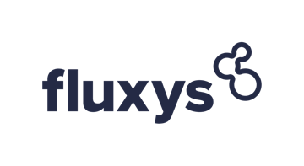

**Regasification Slots available for sale for 2 and 23 December 2022 – Allocation Algorithm**



Allocation mechanism:

* In case Demand is lower than the Offer in the first round, the Auction stops without the Slot being allocated
* In case Demand equals the Offer for a Round:
  + The Cleared Price is the Round Price of that Round
  + Each Participant is allocated its Bid Quantity of that Round
* In case Demand is higher than the Offer for a Round:
  + There is no Allocation
  + The auction goes to another round and a Major Price Step is added
* In case Demand is lower than the Offer after the first Round:
  + There is no Allocation
  + A Minor Price Step is added to the Price of the previous Round
  + Such Minor Price Step is added in next Rounds until Demand equals Offer
* If during the Minor Price Steps the Demand is lower than the Offer
  + Terminal Operator will contact Participants via email having entered a Bid Quantity higher than zero during the previous Round, and ask Participants for a best and final offer on price, to be submitted via following [form](https://www.fluxys.com/-/media/project/fluxys/public/corporate/fluxyscom/documents/fluxys-lng/commercial/information-session/20220603---lng-slot-auction-for-8-july-2022/20220603---schedule-2.pdf) to info.lng@fluxys.com.
  + This best and final offer has to be submitted by Participant within 30 minutes after Terminal Operator has requested this best and final offer on price via electronic mail.
  + The Slot will be allocated to the Participant that submits the highest best and final offer on price. In case the price of the Bids were to be the same, Terminal Operator will allocate the Slot to the Bid that was received first.

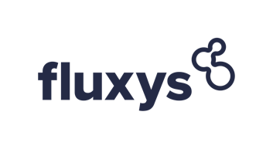

**shaping together**

**a bright energy**

**future**