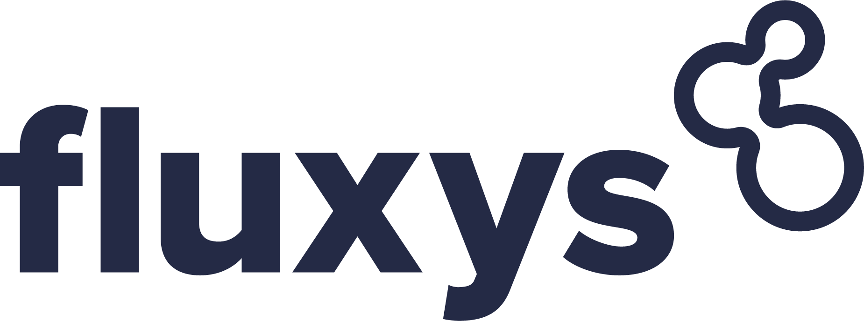
 | 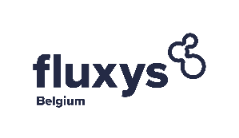 | 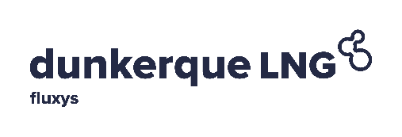
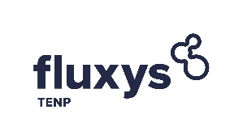 | 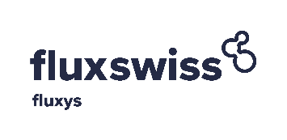 | 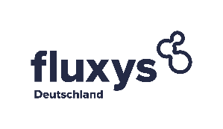

KNOW-YOUR-CUSTOMER FORM

Customer name

In the framework of our due diligence process required for becoming a customer, please fill in and return this form together with the mandatory supporting documents.

Mandatory supporting documents

Please provide the following documents (including a certified translated version in English, French, Dutch or German, if the original version is not in one of the before-mentioned languages):
- The latest commercial registry extract, not older than 3 months.
- The articles of incorporation of the Company.
- The statutory and consolidated financial statements of the last 3 fiscal years, including management and auditor’s report.
- If not already included in the financial statements, a memo describing precisely your activities.
- The powers of attorney of the legal representative who signed this KYC form, and the corresponding passport copy.
- A full list of current authorized signatories and signature specimen.
- The structure chart up to and including the Ultimate Parent level as well as the direct and indirect beneficial owners with minimum of 25% aggregate ownership or comparable control rights (in relationship with question 1 and 2 under the “ownership” section hereafter).

Company profile

In order to analyse your application, please answer thoroughly and complete all the following questions according to Commercial Registry (questions must be answered for the applicant company only – not its group or shareholder).

1 | Company Name
2 | Address
3 | Phone
4 | Email Address
5 | Website
6 | The company is incorporated under the laws of
7 | Registered office
8 | Date of incorporation
9 | City and Registration number
10 | EAN number
11 | EIC number
12 | VAT number
13 | Number of employees
14 | Names of the company’s Managing Director(s) / CEO
15 | Main Business
16 | Countries in which your company is active
17 | Requested start date of the Agreement
18 | Main bank name
19 | Main bank address
20 | Account number
21 | IBAN number
22 | BIC code

Identity

Which category does your company belong to (multiple possible answers)
1. Majority of shares publicly- /state- / municipally owned (>50%) or 100% subsidiary of such a company

2. Exchange listed / exchange traded corporation or 100% subsidiary of such a company

3. Private company

Ownership

1. Who are your direct shareholders/owners, owning more than 25% of your company?
Name | Country of domiciliation | Share (in%)

2. Who are your indirect shareholders (up to the ultimate parent/final beneficiary), owning more than 25% of your company?
Name | Country of domiciliation | Share (in%)

Anti-money-laundering and financing terrorism

1. Does your company have measures/processes on anti-money-laundering (AML), combatting the financing of terrorism (CFT) and “Know-Your-Customer” (KYC) requirements in place?

- ☐ Yes | - ☐ No

2. Does your company regularly train/educate the staff members working in departments responsible for compliance with the relevant AML-, CFT- or KYC- requirements about measures/processes and (if applicable) regulatory requirements?

- ☐ Yes | - ☐ No
3. Has your company been involved in or investigated for (alleged) cases of corruption, AML, CFT, or fraud in the past 3 years?

- ☐ Yes | - ☐ No

Your trading profile and capability to intervene

1. Is your company already admitted/registered on at least one Regulated Market/Exchange?
- ☐ Yes | - ☐ No
If yes, please provide the following details for all these Regulated Markets/Exchanges:
Regulated Market/Exchange | Start date | Type
 |  |  | Directly registered |  | Via
 |  |  | Directly registered |  | Via
 |  |  | Directly registered |  | Via
 |  |  | Directly registered |  | Via

2. Does your company trade on other markets (e.g. Multilateral Trade Facility [MTF], Organized Trading Facility [OTF], Over-the-Counter [OTC]) beside the regulated market places/exchanges stated in the answer to the question above?

- ☐ Yes | - ☐ No
If yes, please provide the following details:
Commodity traded (centrally cleared) | Start date

3. Does your company trade on its own account exclusively?
- ☐ Yes | - ☐ No
If no, on who´s account does your company trade also?
…………………………………………………………………………………………………………..
…………………………………………………………………………………………………………..

4. Do your traders have adequate qualification/experience for trading energy/energy related products (e.g. trader certification/admission to exchanges/other markets)?
- ☐ Yes | - ☐ No

5. Please state on which market segments your company is or wants to become active?

Spot Market | Active | Interest | Futures Market | Active | Interest
CEGH | ☐ | ☐ | CEGH | ☐ | ☐
ETF | ☐ | ☐ | ETF | ☐ | ☐
GPL | ☐ | ☐ | GPL | ☐ | ☐
NBP | ☐ | ☐ | NBP | ☐ | ☐
NCG | ☐ | ☐ | NCG | ☐ | ☐
OTE | ☐ | ☐ | OTE | ☐ | ☐
PEG | ☐ | ☐ | PEG | ☐ | ☐
TTF | ☐ | ☐ | PSV | ☐ | ☐
ZEE | ☐ | ☐ | TTF | ☐ | ☐
ZTP | ☐ | ☐ | ZEE | ☐ | ☐
PVB | ☐ | ☐ | ZTP | ☐ | ☐
Turkish Market | ☐ | ☐ | PVB | ☐ | ☐
Slovak Market | ☐ | ☐ | JKM (Liquid Natural Gas) | ☐ | ☐
Henry Hub | ☐ | ☐ | Henry Hub | ☐ | ☐

6. Does your company physically supply end customers on the retail segment?
- ☐ Yes | - ☐ No

If yes, in which European countries

7. What are your internal facilities dedicated to gas trading?

Gas dedicated facilities | Details
IT solutions / resources / systems / premises
Backup solutions
Dedicated trading floor / size
Other

Signature(s)

We authorize Fluxys and its affiliated companies to use the information given in this form for internal purposes only. To the extent personal data are being processed, Fluxys and its affiliated companies will treat such information in accordance with its privacy policy which is available on https://www.fluxys.com/en/privacy.

We declare in good faith that all information, answers and documents provided with this form are exact and authentic. We have omitted no important information that could have an impact on the judgment you will make about our request for admission.

Place | Date | Legally binding signature(s) of the company
 |  | Signature(s)
 |  | Name(s)
 |  | Signature(s)
 |  | Name(s)
 |  | Signature(s)
 |  | Name(s)

In case your company wants to be active on Distribution Domestic Points in Belgium.
If this applies to your company.
Fluxys Belgium SA, Interconnector (UK) Ltd, Fluxys TENP GmbH, Fluxys Deutschland GmbH, Dunkerque LNG SAS, Fluxswiss Sagl

