Transmission Program
  - Based on version approved by the CREG on 26 May 2023
Based on Article 71 of the Code of Conduct
regarding access to natural gas transmission networks
CONTENTS
CONTENTS 2
disclaimer 3
1 INTRODUCTION 4
2 transmission in belgium 5
2.1 Physical transmission grid in Belgium 5
2.2 Organisation of the Belgian gas market 7
2.3 Main characteristics of the commercial model 8
3 services offered 12
3.1 Entry and exit services on interconnection points and installation points 12
3.2 Services at domestic points 14
3.3 Short haul Services 16
3.4 quality conversion TO H service 16
3.5 Cross Border Delivery Service 17
3.6 ZTP Trading Services 17
3.7 Substitution services 17
3.8 Ancillary services 17
4 service subscription and allocation rules 19
4.1 Primary market 19
4.2 Trading capacity on the secondary market 23
5 Operating rules 23
5.1 Nominations 23
5.2 Metering and allocations 24
5.3 Data transmission 25
5.4 Gas quality requirements 26
6 Balancing regime and allocation settlements in the belux AREA 26
7 Invoicing 28
8 Congestion management 29
8.1 Proactive congestion management policy 29
8.2 Congestion management procedure 29
9 How to contact us 31

disclaimer

This catalogue (the “transmission program”) describes certain information regarding the transmission model and the related services offered by Fluxys Belgium. Please note that the transmission program can be amended from time to time pursuant to the code of conduct (CREG decision (B) 2411 of 31 August 2022). In any case, Fluxys Belgium hereby disclaims any and all responsibility for any changes to the services described in the transmission program which lies outside of its control. Such changes may be the result of inter alia financial and regulatory constraints defined by the relevant regulatory authority or may be imposed by the Belgian or European authorities.
In addition, the information in this transmission program should not be construed as giving rise to any contractual relationship whatsoever between Fluxys Belgium (or any of its affiliated entities) and any interested party.

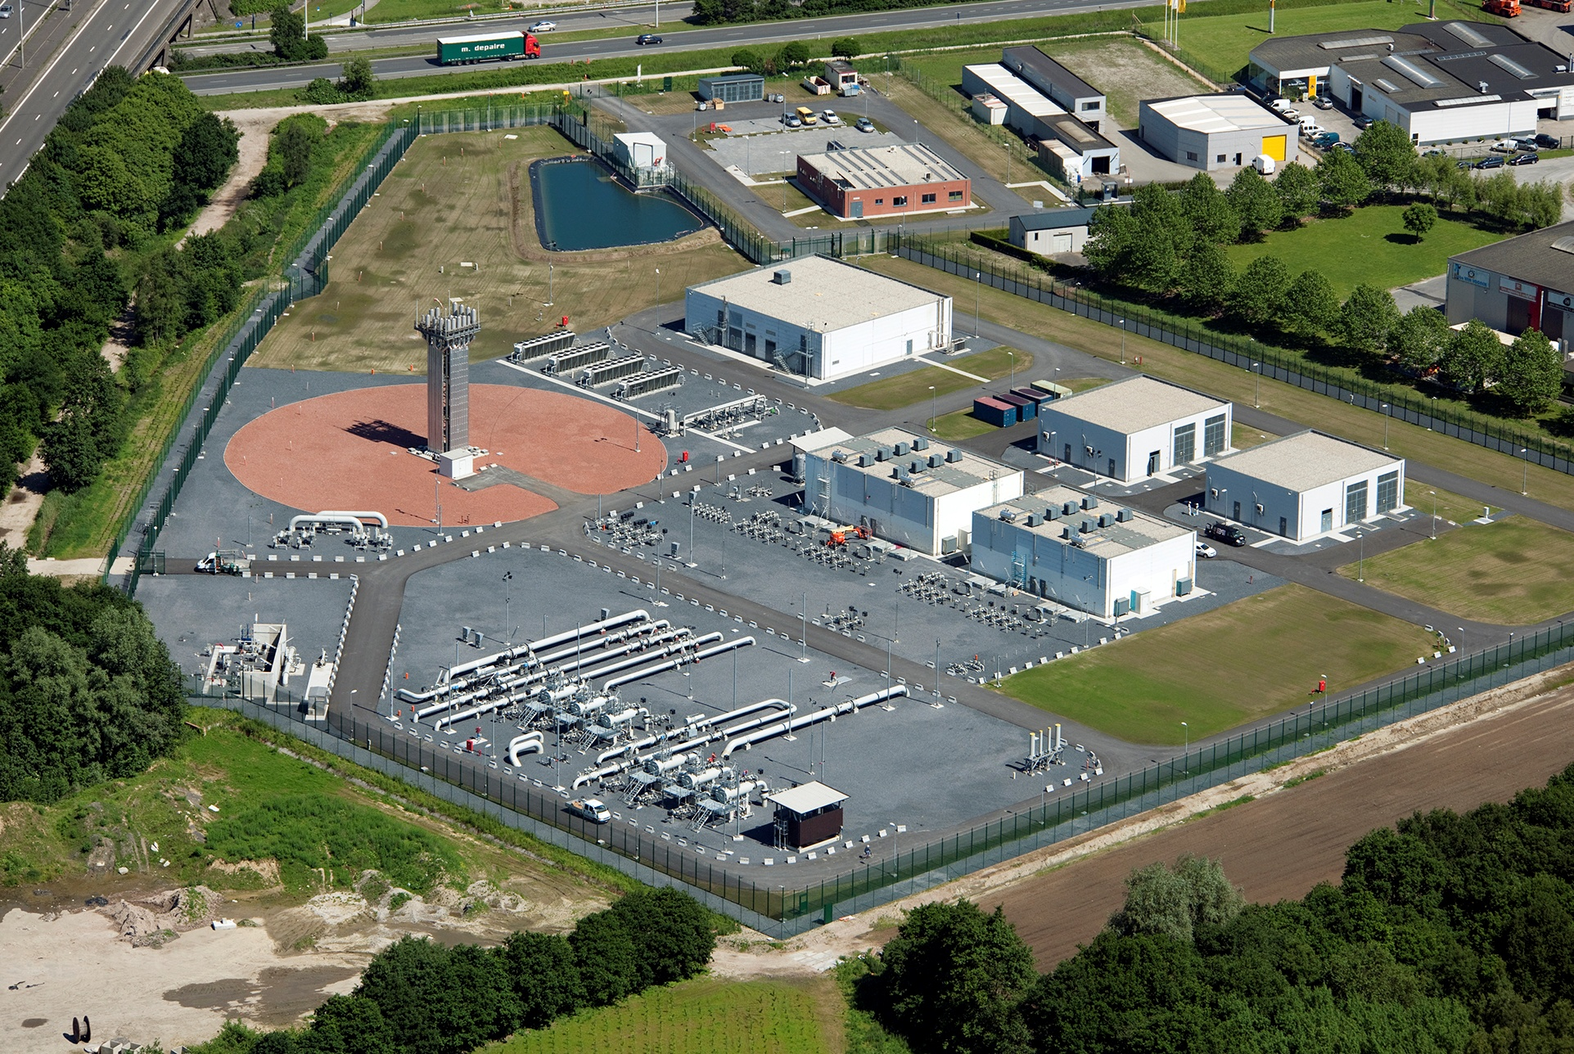

INTRODUCTION
Fluxys Belgium SA is the appointed independent operator of the natural gas transmission grid and storage infrastructure in Belgium (as per the Royal Decree of 23.02.2010). Fluxys LNG, its subsidiary, operates the Zeebrugge LNG terminal. The company has developed its infrastructure in Belgium into the crossroads for international gas flows in North-Western Europe.
Together with CREOS Luxembourg, the company established a cross-border market area – BeLux – and formed a joint venture Balansys to operate the balancing activities in the BeLux market area. General information on how the three companies are associated can be found in the BeLux Integrated Market Model document publisheb on the Fluxys Belgium website.
Fluxys Belgium' gas transmission activities in Belgium, including tariff and balancing aspects, are regulated according to the Federal Act of 12 April 1965 on the transmission of gaseous and other products by pipelines (the Gas Act). This law is supplemented with guidelines on tariffs and by the Code of Conduct,. Fluxys Belgium also abides by the 3rd European Energy Package and associated Network Codes. Her commercial model and services portfolio have been developped to take into account the obligations associated with these regulations.
This Transmission Program describes the transmission services offered by Fluxys Belgium in accordance with the “Standard Transmission Agreement” (contractual terms and conditions), and the “Access Code” (access rules and procedures applicable in Belgium). These documents are developed by Fluxys Belgium in accordance with the code of conduct and, after consultation with the market, are approved by CREG the national regulatory authority of Belgium. These latest approved version of these documents, including the regulated tariffs in force in Belgium, can be found on the Fluxys Belgium website (http://www.fluxys.com/belgium).
This transmission program is intended for information purposes and includes information that is set out in detail in the access code for transmission. Parties wishing to subscribe to the services described below may do so by signing the standard transmission agreement.
Detailed information related to the Loenhout storage facilities and Zeebrugge LNG terminal and their associated services can be found in the storage program and LNG program respectively, both available on the Fluxys Belgium website.
Balancing within the BeLux Area is harmonized and operated by Balansys, the Balancing Operator. Detailed information related to balancing can be found in the Balancing Program.

transmission in belgium

Physical transmission grid in Belgium

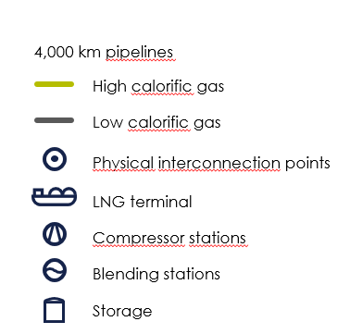
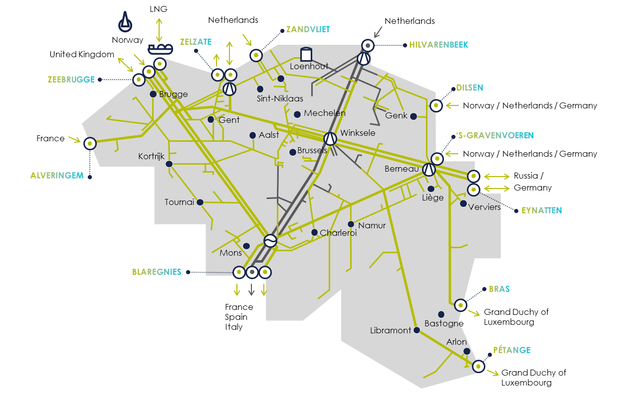
The Fluxys Belgium transmission grid in Belgium has about 4,000 kilometres of pipelines and several physical connections, opening up the Belgian grid to natural gas flows from the United Kingdom, Norway, the Netherlands, Russia and all LNG producing countries. The Fluxys Belgium grid also serves as the crossroads for natural gas transmission flows to the Netherlands, Germany, Luxembourg, France, the United Kingdom and Southern Europe.
Pressure is required to move natural gas through a pipeline network. However, pressure gradually drops due to friction between the natural gas molecules and the pipe walls. The purpose of a compressor station is to maintain pressure in the network. Fluxys Belgium owns and operates 4 compressor stations spread over its transmission grid, located at Weelde, Winksele, Berneau, and Zelzate.
Two different types of natural gas are transported within the Fluxys Belgium grid: high-calorific natural gas (H gas or rich gas), and low-calorific natural gas (L gas or Slochteren gas). Each type of natural gas is transported via dedicated connection points and through specific subgrids (dedicated part of the Fluxys Belgium grid), which are operated independently. They are however connected by quality conversion facilities where gas can be transferred from one subgrid to the other, once the gas quality has been adjusted via mixing or nitrogen blending.
The Fluxys Belgium transmission grid is also connected to other facilities: the Loenhout underground storage facility operated by Fluxys Belgium, the Zeebrugge LNG terminal operated by Fluxys Belgium’ subsidiary Fluxys LNG and the Dunkirk LNG Terminal, connected to the Fluxys Belgium’s grid by means of cross border capacity, and operated by Dunkerque LNG.
The Loenhout underground storage facility is an aquifer storage for high calorific natural gas that combines seasonal storage for up to 700 MCM of workable volume with high flexibility of usage.
The Zeebrugge LNG terminal and the Dunkirk LNG terminal are used to load and unload ships carrying liquefied natural gas (LNG). LNG is temporarily kept in storage tanks at the facility as a buffer before regasifying the LNG and injecting it into the grid for transmission, or loading the LNG back onto LNG ships or trucks (in Zeebrugge LNG terminal only).
With the emergence of green gases from renewable origin (biomethane, green hydrogen, …), a local producer can inject these gases on the transmission network, either directly or via the distribution.

Organisation of the Belgian gas market
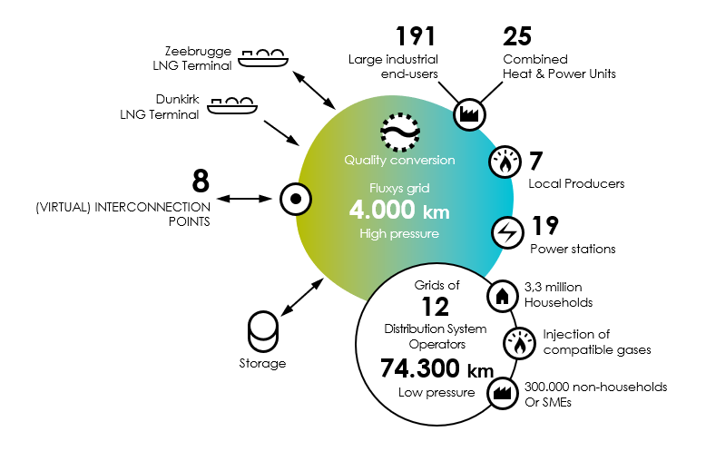
Many parties are active on the Belgian gas market. These parties fulfil one or more of the following roles.
Fluxys Belgium is the transmission system operator (TSO) that owns and operates the Belgian high-pressure natural gas transmission grid. Balansys is the balancing operator of the BeLux market area and offers balancing services to network users active in the BeLux area.
A network user is a company for which Fluxys Belgium transports gas within its high-pressure natural gas transmission grid, using transmission capacities contracted under terms and conditions set forth in the standard transmission agreement which is signed between the network user and Fluxys Belgium.
A distribution network operator is a company that distributes natural gas at a lower pressure to final customers connected to its grid, including households and small and medium-sized enterprises. There are 12 distribution network operators in Belgium connected to the Fluxys Belgium grid through some 70 aggregated receiving stations.
A final customer is the ultimate consumer of the gas and a local producer can inject gas into the network. Final customers and local producers can be directly connected to the Fluxys Belgium grid or connected to a distribution network. There are about 232 companies directly connected to Fluxys Belgium’ natural gas transmission grid, referred to as ‘end users’ and ‘local producers’. They include industrial companies, cogeneration plants, power stations and local gas producing plants. Terms and conditions ruling such physical connections are contractually set forth in the Connection Agreements. On the other hand households, small to medium-sized enterprises and production sites connected to a distribution network have no direct contractual relationship with Fluxys Belgium.
A trader is a party transferring title of gas within the Fluxys Belgium grid thanks to ZTP trading services.

Main characteristics of the commercial model

An entry/exit model with an H-zone and an L-zone
The model under which Fluxys Belgium offers transmission services to network users is an entry/exit model. Through this entry/exit model, natural gas enters the BeLux area at an connection point, and can either leave the transmission grid at another connection point or be traded within the grid. Connection points means interconnection points, installation points and domestic points.
The transmission grid is divided into two entry/exit zones: the H-zone and the L-zone. The H-zone corresponds to the physical H-calorific subgrid and the L-zone to the physical L-calorific subgrid. Entry services enable a network user to inject a quantity of natural gas at a connection point into the considered zone. Exit services enable the network user to withdraw a quantity of natural gas at a connection point from the zone in question. Section 3 contains more information on the entry and exit services.
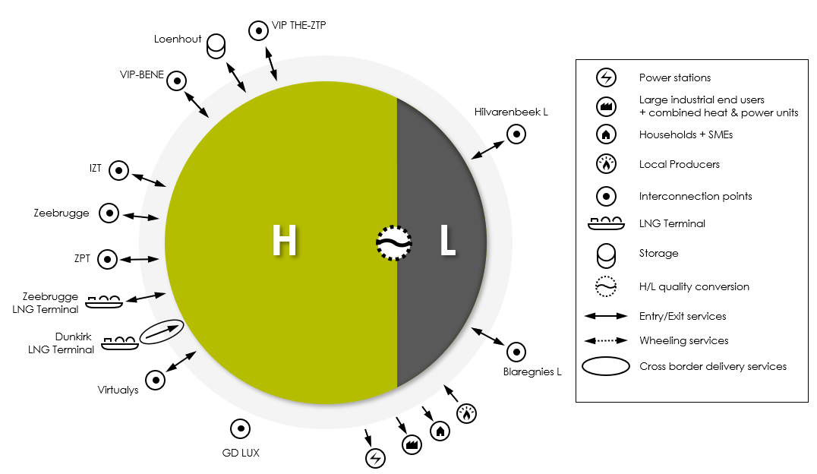
An interconnection point is a type of connection point linking the Fluxys Belgium transmission grid with the transmission grid of an adjacent TSO.

An installation point is a type of connection point linking the Fluxys Belgium transmission grid with an installation operated by Fluxys Belgium or one of its subsidiaries or with an installation connected to the Fluxys Belgium grid by means of a cross border capacity. Those connection points are the quality conversion facilities, the Loenhout storage facility, the LNG terminal in Zeebrugge and the LNG terminal in Dunkirk.

A domestic point is a connectionpoint connecting the Fluxys Belgium transmission grid to a final customer or a local producer, either directly (end user domestic point and domestic point for injection), or via a distribution network (distribution domestic point).

A model interconnecting the Northwest European market areas and Belgian final customers
The Fluxys Belgium transmission grid enjoys a high level of interconnectivity with adjacent transmission grids, offering extensive access to Northwest European market areas and production facilities.

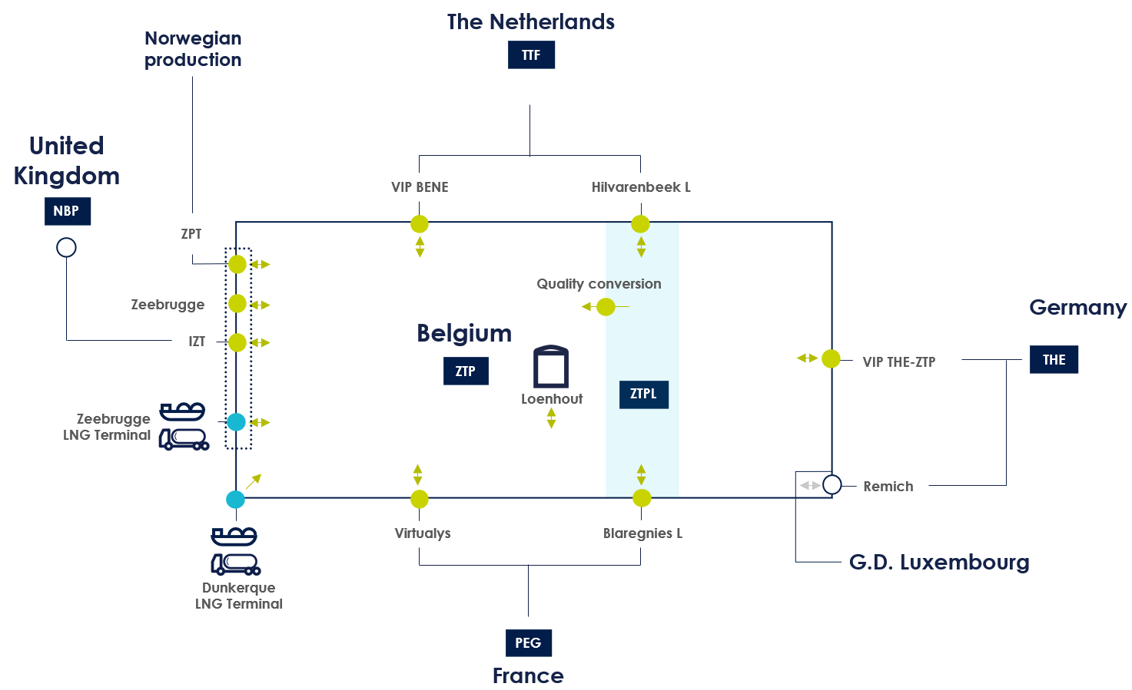
According to EU Commission Regulation 2017/459 (CAM NC), transmission system operators shall offer the available capacities at different Interconnection Points connecting the same two Entry/Exit systems at a Virtual Interconnection Point (VIP).

Interconnection Points and installation points |  | Adjacent Operator / Market Area
Interconnection points (H-gas) | Virtualys | GRTgaz | TRF (PEG)
 | VIP THE-ZTP | Gascade | THE
Open Grid Europe
Thyssengas
Fluxys TENP
 | IZT | Interconnector | NBP
 | VIP-BENE | GasunieTransportServices | TTF
 | Zeebrugge | Fluxys Belgium | -
 | ZPT | Gassco | -
Interconnection points (L-gas) | Blaregnies L | GRTgaz | TRF
 | Hilvarenbeek L | GasunieTransportServices | TTF
Installation points | Loenhout | Fluxys Belgium
 | Zeebrugge LNG Terminal | Fluxys LNG
 | Dunkirk LNG Terminal | Dunkerque LNG
 | QC - Quality Conversion | Fluxys Belgium

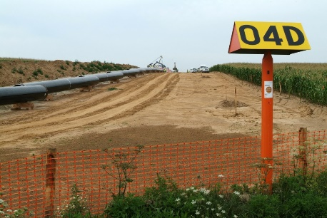

services offered
Entry and Exit Capacity services are available in various capacity types and can be subscribed independently:
- Firm (F) capacity is always available and usable under normal operating conditions.
- Interruptible (I) capacity means that Fluxys Belgium can interrupt the service due to physical restrictions on its transmission grid.
- Backhaul (BH) capacity is offered at unidirectional connection points, in the opposite direction of the physical gas flow direction and is usable as long as the resulting physical flow remains in the physical direction of the connection point.
- Conditional (C) capacity is offered at domestic points and is available as long as the injection of gas at that domestic point is not resulting in an unacceptable accumulation of gas in a certain portion of the transmission grid and as long as the injection of gas at the domestic point is not resulting in the violation of any of the gas quality requirements.

Entry and exit services on interconnection points and installation points
Entry services are services enabling natural gas to be injected into a zone of the transmission grid at an interconnection point or installation point. Exit services are services enabling natural gas to be withdrawn from a zone of the transmission grid at an interconnection point or installation point.
The table below shows the services offered at interconnection points and installation points.
Interconnection Points and installation points |  | Entry service |  |  | Exit service
 |  | F | BH | I | F | BH | I
Interconnection points (H gas) | IZT | X |  | O | X |  | O
 | Virtualys | X |  | O | X |  | O
 | VIP-BENE | X |  | O | X |  | O
 | VIP THE-ZTP | X |  | O | X |  | O
 | Zeebrugge | X |  | O | X |  | O
 | ZPT | X |  | O |  | X
Interconnection points (L gas) | Blaregnies L |  | X |  | X |  | O
 | Hilvarenbeek L | X |  | O |  | X
Installation Points | Loenhout | X |  | X* | X |  | X*
 | Zeebrugge LNG Terminal | X |  | O |  | X
 | Dunkirk LNG Terminal | X
- X = Service is offered and can be contracted within indicative availabilities as published on the Fluxys Belgium website
- X* = Operational interruptible capacity that corresponds to capacities that Fluxys Belgium has secured for the operation of the transmission grid and that are made available to network users on an interruptible basis.
- O = Service is optionally offered

Definition of the service offer at interconnection points and installation points
As long as firm (or backhaul) transmission services are available at interconnection points or LNG Terminal installation points, only firm (or backhaul) transmission services are offered at these interconnection points or installation points, which are allocated as requested or via auctions, as detailed in section 4.1. Subscribed firm transmission services are, subject to the terms and conditions of the standard transmission agreement, always usable under normal operating conditions. For unidirectional interconnection points and installation points, only backhaul services are offered in the reverse direction.Backhaul capacity is usable on selected interconnection points and installation points as long as the resulting physical flow remains in the physical direction of such unidirectional interconnection point or installation point.
Interruptible services are offered at an interconnection point or installation point, when firm transmission services are available in limited quantity over a certain period. The offered quantities are calculated such that the probability of interruption based on historical data does not exceed 10%. This probability is based on historical data and only serves as an indication, without giving any guarantee as to the probability of interruption for the future.Interruptible services can be interrupted by Fluxys Belgium if the requested quantities exceed the physical capabilities.
Operational interruptible capacity is offered at the Loenhout installation point, where Fluxys Belgium has secured capacities for the operation of the transmission grid. In order to maximise the service offer, such operational capacities are made available to network users on an interruptible basis. This service is offered in addition to firm capacity. These firm and operational interruptible services are implicitly allocated by Fluxys Belgium to network users according to the subscribed storage services with Fluxys Belgium at the Loenhout underground storage facility.Operational interruptible capacity offered at the Loenhout installation point can be interrupted by Fluxys Belgium in case such capacity is needed to operate the transmission grid.

Rate type for interconnection points and installation points
Two types of rates apply for entry and exit services at an interconnection point and installation point, depending on the duration of the booked service. If the service period is equal to one calendar year or any multiple of calendar years, the yearly rate type will apply. In other cases (less than one calendar year), a seasonal rate type will apply in proportion to the number of days of the booking.
This is summarized in the following table:
Capacity services | Service period | Rate type
Entry and Exit services | = 1 year or multiple of 12 calendar months | Yearly
 | 1 month=<x<1 year | Seasonal
 | < 1 month

Services at domestic points
Services at domestic points are enabling natural gas to be withdrawn from or injected to a zone of the transmission grid at a domestic point.
 | Connection Point | Firm | Conditional |  | Interruptible
Entry services | Domestic point for Injection | - | X |  | O
 | Distribution Domestic point | - | X |  | -
Exit services | End User Domestic point | X | - |  | O
 | Distribution Domestic point | X | - |  | -

Exit service and entry service offer at a domestic point
For end user domestic points - i.e. connection points between the Fluxys Belgium transmission grid and end users’ facilities - exit service has to be subscribed by the network user. As long as firm exit service is available at an end user domestic point, only firm exit transmission service is offered, which is allocated as requested. This service is offered with high pressure, and PS (pressure service at domestic point) parameters, if applicable, taking into account the physical characteristics of the end user domestic point. For more details on those services, please refer to Section 3.2.4.
For domestic points for injection - i.e. connection points between the Fluxys Belgium transmission grid and local producer’s facilities - entry service has to be subscribed by the network user. As long as firm entry service is available at a domestic point for injection, only firm entry transmission service is offered, which is allocated as requested. This service is offered with the PS (pressure service at domestic point) and QC2HS (quality conversion to H service) parameters, if applicable, taking into account the physical characteristics of the domestic point for injection. For more details on those services, please refer to Section 3.2.4.
If no (or no more) firm transmission services can be offered at an end user domestic point or a domestic point for injection, interruptible transmission services can be offered upon consultation with, and agreement of, the end user or the local producer in question in accordance with the access code for transmission and the connection agreement.
For domestic capacity to/from distribution networks, there is no explicit subscription of exit or entry services by the network user. The peak capacity is calculated based on inter alia the methodology agreed with the distribution network operators. Fluxys Belgium implicitly allocates this peak capacity on a monthly basis to network users based on their market share of final customers and local producers within each distribution network, taking into account the different final customers profile segmentations.

Availability for use of each exit or entry service
Subscribed firm transmission services are, subject to the terms and conditions of the standard transmission agreement, always usable under normal operating conditions.
Subscribed backhaul or conditional transmission services are , subject to the terms and conditions of the standard transmission agreement, usable under normal operating conditions and are available as long as the predefined conditions are met.
Subscribed interruptible transmission services can be interrupted by Fluxys Belgium if the quantities requested to be transported exceed the physical capabilities of the transmission network.

Rate type for domestic points
For services at domestic points, four rate types apply, depending on the service period of the booked service.
If the service period is equal to one year or multiple years (beginning on any date), the yearly rate type will apply. For a service period which is between 1 or 12 months, the seasonal rate type will apply in proportion to the number of days of the booking. For service with a service period of less than one month, the short term rate type will apply.
For exit and entry services at distribution domestic points (towards/from the distribution network) that are allocated by the TSO, the rate type is always yearly.

Capacity services | Service period | Rate type
Exit services at End User Domestic point | = 1 year or a multiple of 12 calendar months | Yearly
 | 1 month =<x<1 year | Seasonal
 | < 1 month | Short term
Entry services at Domestic Point for Injection | = 1 year or a multiple of 12 calendar months | Yearly
 | 1 month =<x<1 year | Seasonal
 | < 1 month | Short term
Entry and Exit services at Distribution Domestic point | All service periods | Yearly
During the start-up and commissioning process, Fluxys Belgium will apply the yearly rate type for a maximum of 6 months if capacity requirements are not on regular basis.

Specific services at the domestic point
At end user domestic points and distribution domestic points, the exit transmission services always include the high pressure exit service and may include one or more of the following :
- Via the pressure service, Fluxys Belgium reduces the pressure at a domestic point for offtake within the contractual minimum and maximum pressure limits.
- The odorisation service consists of Fluxys Belgium injecting an odorant in gas at domestic points where an odorisation facility is operated by Fluxys Belgium.
When a network user subscribes to exit capacity services for a domestic point (or is implicitly allocated such services in the case of distribution) connected to the medium pressure network, equipped with a pressure reduction facility or equipped with an odorisation facility, the pressure service or the odorisation service are automatically applicable.
For two specific case of end users located in Belgium but near a border and directly connected to the transmission grid of an adjacent TSO or to the grid of a foreign distribution network operator, the service allowing this is the dedicated direct line service.
At domestic points for injection, the entry transmission services may include one or more of the following services :
- Via the pressure service, Fluxys Belgium increases the pressure delivered at a domestic point for injection to the operating pressure of the network (local compression) or protects the network from an overpressure that would be delivered by the domestic point for injection (local pressure reducing station).
- The odorisation service consists in Fluxys Belgium injecting an odorant in gas at the Domestic Points for Injection where an odorisation facility is operated by Fluxys Belgium.
- The quality conversion to H service offers the possibility to inject a non compatible gas at domestic points for injection where a blending facility is operated by Fluxys Belgium to mix the non compatible gas with H-gas so that the blend is a compatible gas.

Short haul Services

Zee platform service
The aim of the Zee Platform Service is to facilitate transfers of gas in the Zeebrugge area between IZT, ZPT, Zeebrugge interconnection points and Zeebrugge LNG Terminal installation point. The Zee Platform Service enables network users to transfer natural gas between two or more (at the network user’s choice) of these points without explicit capacity reservation and without any capacity limitation.
Zee Platform transfers are firm, except transfers to ZPT and Zeebrugge LNG Terminal which are backhaul, as ZPT and Zeebrugge LNG Terminal are unidirectional connection points. Furthermore, transfers to IZT and Zeebrugge are subject to compliance with UK gas quality requirements.
The Zee Platform service does not give access either to the entry/exit zone of the transmission grid nor to the ZTP trading services (ZTP & ZTPL). Under the Zee Platform, the quantity of entering gas must be equal, on an hourly basis, to the quantity of exiting gas.

quality conversion TO H service
The quality conversion to H service enable the injection of non-compatible gases in the H-gas already flowing into the transmission system where it can be blended with H-gas so that the mix is a compatible gas. This service is available on an interruptible basis.
The use of quality conversion to H service on the installation point “QC” doesn’t require the network user to subscribe to entry or exit services in the H or L-zone respectively. On that installation point, the quality conversion to H services are allocated as requested as long as they are available and with a minimum period of one gas day.

Quality conversion to H services are also offered at specific domestic points for injection where blending is possible. Quality conversion to H services offered at domestic points for injection are always associated and implicitly allocated together (meaning matched in quantity, time and capacity type) with the subscription of its associated entry.

Cross Border Delivery Service
The cross border delivery service is a service that enables the transportation of natural gas between an interconnection point or an installation point located on an adjacent transmission system operator’s grid and the transmission system of Fluxys Belgium. A cross border delivery service offered on an interconnection point or an installation point is always offered together with other transmission services available on such interconnection point or installation point. The tariff of the respective transmission system operator shall be applicable for the cross border delivery service, as set out in the regulated tariffs.

ZTP Trading Services
Fluxys Belgium offers ZTP trading services enabling network users to exchange title of gas. The ZTP trading services include title tracking, nomination, matching, balance check and confirmation. The details on these services are described in the access code for transmission.

Substitution services

Capacity conversion service
The capacity conversion service enables network users holding unbundled capacity at one side of an interconnection point to convert this capacity into bundled capacity. This service is offered free of extra charge according to the conditions set forth in the access code for transmission.

L capacity switch service
In the framework of the physical conversion of the L-gas network into the H-gas network, the L capacity switch service, , enables network users holding unbundled capacity at an L-gas interconnection point to transfer (part of) that capacity into (un)bundled capacity at an interconnection point or installation point in accordance with the conditions set forth in the access code for transmission.
Entry Transmission Services on L-gas Interconnection points can be switched to Entry Transmission Services on H-gas Interconnection points on a yearly basis. Exit Transmission Services on L-gas Interconnection points can be switched to other Exit Transmission Services on L-gas Interconnection points on a monthly basis.

Diversion service
The diversion service enables network users holding unbundled entry or exit capacity at specific interconnection points or installation point to transfer (part of) that capacity to another interconnection point or installation point at the same grid location (Zeebrugge) in accordance with the conditions set forth in the access code for transmission.

Ancillary services

Real-time data measurement service
The TSO offers a real-time data service which can additionally be subscribed by network users and which provides them with on-line gas flow data (updated every 6 minutes) for selected interconnection points and installation points, privately available on the Electronic Data Platform.

Additional Shipper Code service
Network Users have the possibility to request one additional Shipper Code, in addition to the standard Shipper Code for an activity, for the purpose of Nominations for Entry-Exit activities on the Transmission Network.

service subscription and allocation rules

Primary market
In order to subscribe and use transmission services, a party must first register as a network user, as set out in the code of conduct, which entails signing the standard transmission agreement. The standard transmission agreement is concluded for an indefinite period and service confirmation forms are the legal and contractual form that confirms the subscribed services under this agreement.
Transmission service are offered as follow:
Sales channel | Allocation method | SERVICES |  | Duration
PRISMA | Auction | Entry and Exit Services on IPs, VIPs & LNG Terminals | Blaregnies L | Y, Q, M,  DA, WD
 |  |  | Hilvarenbeek L
 |  |  | IZT
 |  |  | VIP-BENE
 |  |  | VIP THE-ZTP
 |  |  | Virtualys
 | FCFS |  | Zeebrugge | Any duration
 |  |  | ZPT
 |  |  | Zeebrugge LNG Terminal
 |  |  | Dunkirk LNG Terminal
 |  | Capacity Conversion Service (unbundled to bundled) |  | Y, Q, M, DA
 |  | Quality Conversion to H Service at installation point “QC” |  | Min 1 GD
 |  | Exit Service for End Users Domestic point |  | Min 1 GD
 |  | Entry Service for Domestic Point for Injection |  | Min 1 GD
Implicit |  | Zeebrugge |  | B-o-D
 |  | Entry and Exit Services on Loenhout |  | Any duration
 |  | Exit Service for Distribution Domestic point |  | Any duration
 |  | Entry Service for Distribution Domestic point |  | Y
 |  | Other Services | Zee Platform | Not applicable
 | Not applicable |  | ZTP Trading Services
 |  |  | L Capacity Switch Service
 |  |  | Diversion Service
 |  |  | Additional Shipper Code
 | Pro rata | Entry Dunkirk LNG Terminal |  | Duration according to “Call for Market Interest” allocation of send out capacity
Services on interconnection points offered on the PRISMA capacity booking platform (www.prisma-capacity.eu) can be subscribed via auction on a first-committed-first served basis. Other services described in this brochure can be subscribed at Fluxys Belgium either in writing (letter or email), using a transmission service request form (the templates are available on the Fluxys Belgium website), or by on-line booking, using PRISMA or via an implicit allocation.

Subscription via PRISMA
PRISMA European Capacity Platform is a joint initiative developed in cooperation with neighbouring EU transmission systems operators with the goal to implement a joint platform implementing of the European Network Code for Capacity Allocation Mechanisms (“CAM NC”).
On PRISMA, Entry and Exit services at interconnection points can be subscribed in the form of bundled products with the relevant adjacent transmission system operators or in the form of unbundled products with Fluxys Belgium.
On PRISMA, Entry and Exit services can either be subscribed using the first-committed-first-served principle or in auctions.
On PRISMA, the unbundled capacity services offered using the first-committed-first-served principle can be booked at any time taking into account a minimum leadtime of 120 min and this on 24/7 basis. Services are marketed in non-standardized durations, which can either be within-day products (balance of gas day product) or products with a minimum period of 1 day and for which there is no maximum period. These capacity services are allocated in the order as they have been requested, for as long as capacity services are available.
On PRISMA, capacity services offered in auctions are marketed in standardized durations, called standard products, which can either be within-day (balance of gas day product), daily (for a duration of one gas day), monthly (from 1st gas day to last gas day of any calendar month), quarterly (starting on the 1st of October, 1st of January, 1st of April or the 1st of July respectively) or yearly (starting on the 1st of October).
If applicable, for services auctioned on PRISMA, the interruptible services will be offered after the closure of the firm auctions for the same product period. For the remaining interconnection points, interruptible capacities are allocated as requested.
In accordance with the article 3 paragraph 5 of the CAM NC, competing auctions may be set up. These auctions provide the TSO the ability to offer a limited amount of capacity available in two different auctions, where the market indicates via the auction process which auction is the most requested. This is the case for the 1-N auctions situation, where N can be the number of TSOs at one side of the border (or can be the number of products available at one side of the border (e.g. IZT).
On PRISMA, auctions are held according to a European-wide agreed calendar which is determined annually and published on ENTSOG website, but reflected on PRISMA and on Fluxys Belgium websites as well.
The auction premium that can result from the auction process applied to allocate the bundled products is split between Fluxys Belgium and the concerned adjacent transmission system operators in accordance with a key subject to approval by the competent regulatory authorities. The part of such auction premium relating to the services subscribed with Fluxys Belgium is invoiced to the network users by Fluxys Belgium on top of the reserve price being the regulated tariff, according to section 7.
On PRISMA, auctions are held according to two possible algorithms: ascending clock or uniform price.

Ascending Clock
For the auctioning of yearly, quarterly and monthly services, an ascending clock auction algorithm is applied.
During consecutive bidding rounds, network users are invited to submit quantity bids. A quantity bid specifies the amount of capacity that the network user would like to acquire at the proposed price of such bidding round. The reserve price in the first bidding round is equal to the sum of the reserve prices at each side of the interconnection point, with such reserve price being the regulated tariff for the Belgian part of the bundled products. In subsequent bidding rounds, the price for the bundled products is increased by fixed large price increments until the sum of the submitted bid quantity bids is smaller than or equal to the amount of capacity offered.
At that stage, the price is brought back to the price of the previous bidding round. A new series of bidding rounds is launched, in which the price is subsequently increased by small price increments until the sum of the submitted quantity bids is lower than or equal to the amount of capacity offered. In this case the auction is finished. The capacities are allocated according to the last quantity bids at the premium, equal to the sum of the large price increments and small price increments having led to the last bidding round, to be added to the sum of the respective reserve prices
For each product the large and small price increments are fixed, defined and published on www.prisma-capacity.eu. The amount of capacities offered is published at www.prisma-capacity.eu before the beginning of each auction and in a timely manner.

Uniform Price
For the auctioning of daily and within-day services, a uniform price auction algorithm will be applied:
Network users submit their bids or bidding lists during only one bidding round. A bidding list can contain up to 10 bids. Each bid contains the requested capacity amount, the minimum capacity amount and the price at which the network user would like to acquire this capacity amount, it being understood that the reserve price is equal to the sum of the reserve prices at each side of the interconnection point, with such reserve price being the regulated tariff for the Belgian part of the bundled products.
At the end of the bidding round, capacity is allocated to the bids in function of their price ranking, i.e. the requested capacity amount of the bid with the highest price is allocated first. After each allocation, the remaining unallocated capacity is reduced by the same quantity. Each bid is considered successful if capacity can still be allocated in accordance with the minimum capacity amount requested in the bid. All successful bids are allocated at the price of the lowest successful bid if demand exceeds the offered capacity. In all other cases, all successful bids are cleared at the reserve price.

Subscribing services with Fluxys Belgium directly.
Beside the services exclusively offered on PRISMA, other services can be booked at any time in writing as fall-back solution.
Services are offered for a minimum period of one day (gas day from 6:00 AM to 6:00 AM) and there is in general no maximum period, except for the services where another period is explicitly determined (interruptible, … – see section 3.)
In general, services not offered on PRISMA, are allocated as requested, with the exception of services offered in a subscription window, implicitely allocated, through an Open Season process or Incremental Process. Fluxys Belgium allocates these services based on the order of receipt of network users’ applications.

Services implicitly allocated by Fluxys Belgium
There are 4 types of services implicitly allocated by Fluxys Belgium, where the network user has no need to subcribe capacity for using services.
For domestic exit and entry capacity to distribution networks, Fluxys Belgium implicitly allocates the peak capacity on a monthly basis to network users based on (i) for exit capacity: their market share of final customers within each distribution network, taking into account the different final customers profile segmentations (see section 3.2.1) and (ii) for entry capacity their market share of local producers.

The firm and operational interruptible services at Loenhout are implicitly allocated by Fluxys Belgium to network users according to the subscribed storage services with Fluxys Belgium at the Loenhout underground storage facility (see section 3).
Fluxys Belgium will implicitly allocate entry or exit transmission services at interconnection point Zeebrugge if the network user has no more unused entry or exit capacity in its portfolio.
Interruptible services are implicitly allocated by Fluxys Belgium to network users in case overnomination is being activated for such connection point and insofar network users are requesting interruptible services by sending nominations which exceed their subscribed capacity.

Incremental capacity process and Open Seasons
Fluxys Belgium can assess the market potential for new capacity to be developed by means of Open Seasons or Incremental Capacity Process as defined in the Access Code for Transmission. At least every odd year, and at the latest 16 weeks after the start of the annual yearly auctions, Fluxys Belgium will, jointly with its Adjacent TSOs, publish a Demand Assessment Report, analysing the market demand and potential for new or incremental capacity at interconnection points, and concluding on the need – nor absence thereof – to further proceed with incremental capacity projects.

Trading capacity on the secondary market
Network users are legally bound (pursuant to Article 20 of the code of conduct) to make available on the secondary market, the subscribed firm capacity which they no longer need, for a specific period or permanently.
Fluxys Belgium organises the secondary market by enabling network users to trade capacity services they no longer need on an electronic market platform, Fluxys Belgium uses PRISMA (“PRISMA secondary”) for such purpose.
PRISMA secondary allows network users to trade capacity services among themselves or with the TSO, either anonymously or through registration of over-the-counter transactions.
Aside from PRISMA secondary, transmission services can always be traded on the secondary market by a standard written “over the counter” assignment procedure which is detailed in the access code for transmission.

Operating rules

Nominations
In order to notify Fluxys Belgium of the quantity of natural gas that will be (re)delivered at each connection point, , the network user shall send nominations and, if applicable, renominations to Fluxys Belgium, according to the procedure detailed in the access code for transmission. No nominations have to be sent for distribution domestic points.
A nomination is a standardised electronic message issued by the network user via Edig@s protocol. It relates to a particular gas day (a gas day begins at 06:00 hours and terminates at 06:00 hours the following day, Belgian time) and to a specific point, and provides for each hour of the relevant gas day the quantities of natural gas, expressed in kWh, that the network user wishes to inject or offtake under its subscribed services at the relevant point.
The time schedule for the nominations and the renominations cycles for a given gas day are described in the access code for transmission and are based on the EASEE-gas common business practice. The first nomination cycle begins at 14:00 hours of the preceding gas day and is composed of the following steps:
- The network user sends his nominations to Fluxys Belgium
- Fluxys Belgium checks the validity of the message format
- The nominations are processed by Fluxys Belgium (conformity checks and matching with the nominations in the adjacent system)
- Fluxys Belgium computes the quantities that can be confirmed and that are scheduled to be delivered/offtaken to/from the transmission grid
- Fluxys Belgium sends a confirmation message in order to communicate to the network user the results of the process.
Fluxys Belgium supports both double sided nominations and single sided nominations. In double sided nominations, matching nominations have to be submitted to both Fluxys Belgium and the Adjacent TSO, while in single sided nominations only one nomination is required with one of the TSOs The TSOs have to define in which network the network users will be the active and the passive network users, whereby the active network user is sending the nominations as described above towards the active TSO. The passive network user will have to send only once a declaration notice to the passive TSO. Both network users will receive, after conducting a capacity check, the confirmation of the active and/or passive TSO.
The network user may revise its nominations on a day-ahead or Within day basis by sending renominations. During the gas day a renomination is considered valid when received before the applicable minimum renomination lead time and will be processed for confirmation according to the same process as described above. The standard minimum renomination lead time is “full hour + 2”. For net confirmed title transfers (NCTT_{h,z}) relating to ZTP trading services, the notification is accepted until 30 minutes before the considered hour.

Metering and allocations
The metering procedures are specified in the access code for transmission. Based on the metering services that cover metering at metering facilities, validation of measurements and measurement repatriation, Fluxys Belgium allocates gas quantities at the connection points s on an hourly basis to the involved network user(s). The unit used for the allocation is the kWh.
Two types of allocations can be distinguished. The first is the provisional allocation which is based on the hourly provisional measurement and is communicated to the network user within 30 minutes after the hour to help him steer its balancing position. In the second type, the validated allocation which is based on the validated measurements Fluxys Belgium determines at the latest on the 20th day of the month following the month for which the allocations are to be validated and which are used for the final gas settlements between Fluxys Belgium and the network user.
Two types of gas allocation rules can be distinguished at the interconnection points and installation points. First, the “deemed to confirmed nomination” rule where the allocated energy equals the last confirmed energy nominations as confirmed by the adjacent TSO. Second, the “proportional to measurement” rule where the allocations will be proportional to the energy measurements.
For the end user domestic points and the domestic points for injection, the energy allocation allocated to the network users shall be determined according to the allocation agreement valid for this connection point (agreement between Fluxys Belgium, the end user or local producer and the network users supplying natural gas to or injecting from the said end user or local producer). The pooling of capacity is possible at end user domestic points to allow network users supplying the same end user to pool and share each other’s entire subscribed exit capacity for such end user domestic point. The pooling of capacity needs to described in the specific allocation rule at the given end user domestic point on which concerned network users need to agree upon in the allocation agreement, as detailed in the access code for transmission.
For the distribution domestic points, the allocation is based on the telemetered value at the connection point with the distribution network, and based on the network user’s portfolio of local producers and final customers on that distribution network, who can be either telemetered final customers and local producers or profile-based final customers. Furthermore, an imbalance smoothing profile, aiming at neutralising, on a daily basis, part of the imbalance caused by the hourly profiled flow on the distribution networks, is allocated to the network users for their final customers on the distribution networks. The hourly imbalance smoothing allocations of each network user are calculated according to the total forecasted flow of the distribution networks and the provisional allocations for each network user to the distribution networks, as described in the access code for transmission. They are communicated to the relevant network users by Fluxys Belgium on a day-ahead basis and indicatively forecasted for the next 3 days.

Data transmission
In accordance with transparency obligations under European regulation and the Belgian code of conduct, Fluxys Belgium publishes information on the operational data of its transmission grid on its website (http://www.fluxys.com/belgium) where market parties can find a variety of useful information. Data for all relevant parameters are updated hourly or daily as the case may be and users can retrieve customised reports tailored specifically to their needs.
The following information (and more) is publically available on our electronic data platform:
- Interconnection points and installation points: capacities, nominations, allocations and flows
- Consumption: capacities, nominations, allocations and flows for domestic consumption
- Secondary market: capacities traded on the secondary market and their average price
- Temperatures: daily equivalent and degree-day temperatures and their forecast
- List of end users connected to the Fluxys Belgium transmission grid
- Pre-defined reports: supply, demand, storage and LNG reports using a predefined selection of criteria in accordance with ENTSOG guidelines (European Network of Transmission System Operators for Gas).
As part of the standard transmission agreement or connection agreement Fluxys Belgium also provides personalised data services via the electronic data platform, yet only privately accessible to network users or end users, that allows them to visualize, consult or download their own individualised operational data such as:
- hourly measurements including volume, pressure and gross calorific composition of the natural gas at the connection points where they are active;
- hourly allocation data for the connection points where they are active;
- all data required to check Fluxys Belgium invoices.
Fluxys Belgium furthermore offers a real-time data service which can additionally be subscribed by network users and which provides them with on-line gas flow data (updated every 6 minutes) for selected interconnection points, privately available on the electronic data platform.

Gas quality requirements
The Fluxys Belgium website (http://www.fluxys.com/belgium) provides the technical specifications in force for all the interconnection points, the installation points and the domestic points for injection on the Fluxys Belgium grid for gas entering or leaving the grid. Operational rules are explained in the access code for transmission. Furthermore, exits towards IZT and Zeebrugge are subject to compliance with UK gas quality requirements. Fluxys Belgium will use its reasonable endeavours to bring gas exiting IZT within UK Wobbe specifications. If taken measures prove insufficient, Fluxys Belgium has the possibility to constrain the exit gas towards IZT and/or Zeebrugge of Network users, in proportion of the gas they injected within the transmission grid which was off-specification with regards to UK Wobbe specifications.

Balancing regime and allocation settlements in the belux AREA
Balancing services are operated by the Balancing Operator (Balansys). As prerequisite to the use of services within the BeLux area and to the use the of the trading services offered by Fluxys Belgium, a network user is required to subscribe a Balancing Agreement with the Balancing Operator, unless explicitly expressed otherwise. The Balancing Agreement is available on Balansys website (www.balansys.eu).
Balancing services operated by the Balancing Operator are based on provisional data (H+1). The quantity to be settled for a given gas day for a network user, in a given Zone is calculated as the sum of the difference between the provisional and the final data and are settled between the grid user and the concerned TSO of the Belux area.
In case of difference, settlement is calculated at the latest on the 20th day after the relevant month and will be financially handled during the next invoicing cycle.

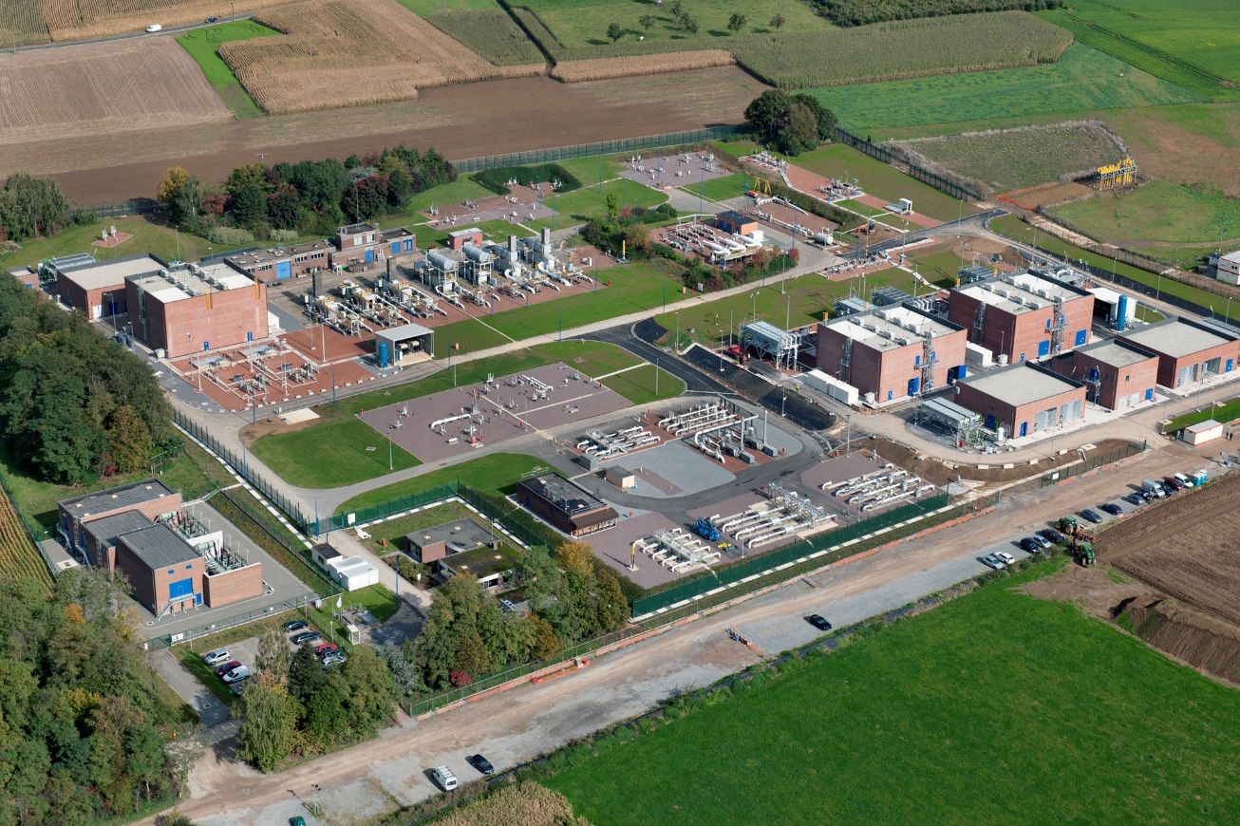

Invoicing
According to the terms and conditions set forth in the standard transmission agreement, invoices are usually issued monthly by Fluxys Belgium to network users, on the 10th day of the month. Invoices will be rendered either electronically either by letter or email.
If the Network User has subscribed to e-invoicing, he will receive a duplicated copy of his invoices by email and will have the opportunity to download his original invoices with their attachment on the Electronic Data Platform.
If the Network User has not subscribed to e-invoicing, he receives his original invoices by letter or email and has the opportunity to download his duplicated invoices’ copies with their attachments on the Electronic Data Platform.
Generally speaking, invoices are due within 30 days after receipt and failure to respect terms of payment may lead to the provision of financial security by the network user or the suspension of such services.
As detailed in the attachment A of the access code for transmission, two types of invoice are issued to network users with respect to the total monthly fee for their subscribed services:
- Monthly invoice, and
- Monthly self-billing invoice.
The monthly invoice on the 10th day of a given month M will contain:
- The monthly capacity fees relating to subscribed or implicit allocated services, including additional services, for month M and additionally subscribed services in month M-1 and not already invoiced in M-1.
- The monthly capacity fees relating to distribution domestic services, provisionally allocated for such month M and the correction for such fees relating to distribution domestic services, finally allocated for month M-3.
- The monthly fix fees relating to the ZTP trading services for the month M.
- The monthly commodity fee (relating to relevant connection points) for month M-3.
- The monthly allocation settlement fees in case of purchase for month M-3.
- The monthly odorisation fee for end user domestic points for month M-3.
- The monthly transmission imbalance fee for month M-3.
- The monthly variable fee relating to ZTP trading services for month M-3.
- The monthly incentive fees for month M-3.
- The monthly administrative fees for month M.
The monthly self-billing invoice on the 10th of a given month M will cover:
- The monthly allocation settlement fees in case of sale for month M-3.
The additional back-billing (if any correction has to be done) are made once per quarter (March, June, September and December).

For the sake of convenience a summary of the consolidated invoices by due date will be transferred to the network user for each month, including a summary note with the balance payable to the TSO or refund to the network user.

Congestion management

Proactive congestion management policy
In accordance with its obligations set out in the code of conduct, Fluxys Belgium applies a proactive congestion management policy aiming to achieve optimal and maximal utilisation of available capacities and prevent congestion. This policy, detailed in the access code for transmission, is based on the following set of measures.
A secondary market is organised by Fluxys Belgium as detailed in section 4.2, via an electronic capacity trading platform, Prisma, enabling network users to offer the subscribed transmission services they no longer require to other network users. This allows for the optimal and market-based distribution of transmission services amongst network users and is supported by the regular publication by Fluxys Belgium of aggregated volumes and average prices of the services traded on the secondary market.
Interruptible capacities are offered at connection points as detailed in section 3. Such interruptible services enable the dynamic recycling of unused subscribed firm transmission services to other network users.
Fluxys Belgium also encourages the utilisation of subscribed transmission services by keeping an electronic register of the utilisation rate of subscribed transmission services for each network user and for each service. This register is submitted to CREG at least annually, as set out in the code of conduct. Each network user is also provided with part of the register concerning his individual data.
Network users have furthermore the possibility to post firm transmission services they wish to sell at Fluxys Belgium (surrender of contracted capacity). Interested network users are allowed to respond to this offer, either directly or via PRISMA.
Furthermore, as another measure to apply a proactive congestion management policy, Fluxys Belgium allows the conversion of entry and exit services into wheeling and/or operational capacity usage commitment under defined conditions (see 3.3 and 4.1).

Congestion management procedure
Congestion occurs when a service request for firm transmission services at a connection point cannot be confirmed due to the lack of available firm transmission services and if none of the proactive congestion management measures detailed in the access code for transmission or any other alternatives envisaged between Fluxys Belgium and network user have provided for an acceptable solution.

Interconnection Points
In consequence of Annex 1 of the Regulation (EC) No 715/2009 three (3) specific congestion management procedures are applicable on interconnection points in particular:
- “surrender of contracted capacity” as congestion measure against contractual congestion, in order to bring unused capacity back to the market, as decribed in section 8.1;
- “long-term use-it-or-lose-it mechanism” in order to bring unused capacity back to the market upon decision of CREG or;
- “capacity increase through oversubscription and buy-back scheme” in order to create additional firm capacity.

Long-term use-it-or-lose it mechanism
The “long-term use-it-or-lose-it” procedure is designed to release all or part of the unused subscribed firm transmission services of network users, upon decision of CREG. The TSO, on behalf of network users, shall offer the released services on the primary market per periods of 2 months as foreseen in the code of conduct .
This release will be performed after notification to the relevant network users of the amounts subject to possible release. In the absence of response from the network user within the scheduled period, such amounts will be automatically released on the secondary market. However, a response from the network user will lead to a decision of the CREG on the quantities which are finally released and effective.

Capacity increase through oversubscription and buy-back scheme
In order to solve contractual congestion Fluxys Belgium may offer firm transmission services in the framework of oversubscription, on top of the technical capacity. In determining this oversubcription firm capacity, Fluxys Belgium will take into account:
- statistical scenarios for the likely amount of physically unused capacity at any given time at interconnection points;
- technical conditions, such as the gas gross calorific value, temperature and expected consumption; and
- a risk profile for offering this additional firm capacity which does not lead to excessive buy-back obligations.
Where necessary to maintain system integrity, Fluxys Belgium will apply a market-based buy-back procedure in which network users can offer firm transmission services back to the TSO.

End user domestic points and installations points
For end users domestic points and installations points, a long-term use-it-or-lose-it can be applied. This mechanism is similar to the mechanism applied for interconnection points in section 8.2.1.1.

How to contact us
Any request for additional information or questions in relation to the service offer should be addressed to:

Fluxys Belgium SA/NV
Direction Commercial Regulated
Avenue des Arts, 31
1040 Brussels
Belgium

    - E-mail: info.transport@fluxys.com or marketing@fluxys.com

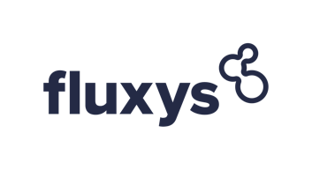
shaping together
a bright energy
future

A code of conduct (Decision CREG (B)2411 of 31 August 2022) establishes the rules governing access to the transmission grid, storage facilities and LNG facilities
Regulation (EC) No 715/2009 of the European Parliament and of the Council of 13 July 2009 on conditions for access to the natural gas transmission networks and repealing Regulation (EC) No 1775/2005
A connection point is a physical or a virtual point on the transmission grid, as specified in the access code for transmission, at which network users deliver natural gas to Fluxys Belgium for the performance of transmission services or at which Fluxys Belgium redelivers natural gas to network users after having performed such transmission.
IZT interconnection point connects to the National Grid’s NBP through the undersea Interconnector pipeline .
Which are subject to the terms and conditions of the standard transmission agreement.
With the subscription of Dunkirk LNG Terminal the associated Cross Border Delivery Service will be implicitly allocated meaning that they are matched in quantity, time and Capacity Type as described in ACT – Attachment A.
Except for Installation Points Dunkirk LNG Terminal
Written procedure can be activated by Fluxys Belgium as fall-back mechanism, should PRISMA or EBS platforms be unavailable. Entry and Exit Services on IPs, VIPs and LNG Terminals, Quality Conversion Services and on Domestic Points can also be implicitly allocated by Fluxys Belgium to network users in case overnomination is being activated for such Connection Point. Overnomination will be activated when all Firm Transmission Services are sold after the Firm Day-Ahead auction and after the Interruptible Day Ahead auction if any or as a fall-back mechanism when PRISMA platform should be unavailable.
(Y)= Yearly, (Q)= Quarterly, (M)= Monthly, (DA)= Day-Ahead, (WD)= Within-Day, (WD24h)= Within- Day product containing maximum number of Hours in a Gas Day being 23/24/25 Hours, (B-o-Y)= Balance of Gas Year, (GD)= Gas Day, (B-o-D)= Balance of Gas Day .
Implicit allocation of Transmission Services at Zeebrugge possible.
With the subscription of Dunkirk LNG Terminal entry capacity the associated Cross Border Delivery Service will be implicitly allocated meaning that they are matched in quantity, time and Capacity Type as described in ACT – Attachment A. No capacity will be allocable for a service period shorter than 1 gas day. No entry capacity is offered under the FCFS principle during a “call for market interest” (“CMI”) process organized by the Dunkerque LNG Terminal unless for a period until the beginning of the period concerned by the CMI process.
When “Call for market interest” organized by Dunkirk LNG Terminal takes place, Dunkirk LNG Terminal entry capacity can be requested via written request. The written request for the Dunkirk LNG Terminal Entry capacity is possible until 5 calendar days after the final allocation of the Dunkirk LNG Terminal Send Out capacity (allocated as part of the CMI-process and/or the spare capacity allocation-process). The allocation of the Dunkirk LNG Terminal Entry capacity is done as of the 6th calendar day after the final allocation of the Dunkirk LNG Terminal Send Out capacity with a duration that is no longer than the allocated Dunkirk LNG Terminal send out capacity resulting from the final allocation of the Dunkirk LNG Terminal Send Out capacity. If the demand is higher than the offer, Services will be allocated pro rata the Dunkirk LNG Terminal Send Out capacity that has been allocated as part of the CMI-process and/or the spare capacity allocation-process and the pro rata rule will be applied for each calendar year individually. With the subscription of Dunkirk LNG Terminal entry capacity the associated Cross Border Delivery Service will be implicitly allocated meaning that they are matched in quantity, time and Capacity Type as described in ACT – Attachment A. .
If PRISMA is not available, the TSO retains the option to offer the available capacity in writing. During this period of unavailability of the platform, the network user has the right to send the requests directly to the TSO in the correct form.
Commission Regulation EU (No) 984/2013 (CAM NC) has entered into force after its publication in the Official Journal of the European Union in late 2013 and is applicable since 1 November 2015; the allocation processes on PRISMA are based on this official version of the CAM NC.
Being the sum of subscribed capacities on interconnection points Zeebrugge, ZPT, IZT and installation point Zeebrugge LNG Terminal.
EASEE-gas Common Business Practice 2003-002/01 “Harmonisation of the Nomination and Matching Process”, as approved on February 18, 2004 (see http://www.easee-gas.org/cbps.aspx)
The difference between the sum of the hourly allocated quantities and the metered quantities will be allocated to an operating balancing account (OBA) held between Fluxys Belgium and its adjacent TSO or any other party
Note that allocation data is also provided via standardized electronic messages based on the Edig@s protocol.
Conversion will no longer be possible as from July 1st 2023

