Additional Storage and Priority Booster Capacity – 02-03/2024

Terms and Conditions of the Auction Window

Terms and Conditions
These Terms and Conditions for the Auction Window (TCAW) for participating to the Auction for Additional Volume and Priority Booster Capacity organized by Storage Operator are entered into between:

- Fluxys Belgium NV/SA, a public limited company organized and existing under the laws of Belgium, having its registered office at 1040 Brussels, Avenue des Arts 31, entered in the registry for legal entities under the number 0402.954.628, here duly represented by
Damien Adriaens
Deputy Director Commercial Regulated

Hereafter referred to as “Storage Operator”

And

- ……………………….., a company organized and existing under the laws of…………, having its registered office at ………………………, entered in the Company Register under the number……………………, here duly represented by

[First name, Surname,  position] | [First name, Surname,  position]

Hereafter referred to as “Applicant” and, when and if successfully registered by the Storage Operator, as “Participant”.

The Storage Operator and Applicant or Participant, depending on the status of the Auction Window, may hereafter be individually referred to as a “Party” and collectively as the “Parties”.
Done in ……………………………….., on ……………………………… in two copies, each Party acknowledging receipt of its copy.

Whereas:
- The Parties have entered into a Standard Storage Agreement (“SSA”);
- Additional Volume and Priority Booster Capacities on offer by the Storage Operator are limited and allocated to the interested entities through a market mechanism, being an auction process;
- In the framework of the SSA, the Storage Operator is willing to offer to the Applicant the possibility to subscribe Additional Volume and/or Priority Booster Capacities by participating to an Auction Window under the terms and conditions as set forth in this TCAW. This TCAW describes in further detail under which terms and conditions access is granted to the Auction Window and under which terms and conditions the Participant, that wishes to acquire Storage Services, can submit a Bid and as the case may be, be granted Storage Services.

Interpretation
In this TCAW:
- all references to a clause/section, unless specified otherwise, are references to a clause/section in this TCAW; references to a paragraph are references to a paragraph in this TCAW;
- all terms and names are to be interpreted according to the list of definitions of attachment 3 of the Standard Storage Agreement;
- the layout, heading and (sub)sections are only for the benefit of the reader and are inconsequential as regards the interpretation of content of this TCAW;
- the description of rules, conditions and provisions only relates to the Storage Services offered via this TCAW;
- all dates and time are referred to as in Belgium local time.

Introduction

Scope
The Storage Operator will be allocating Additional Volume and Priority Booster Capacities (PBC) as defined in detail in chapter 2.2 through one Auction Window using an Auction Form. The Services offered on the Auction Form by the Storage Operator are bound by the provisions of both the Access Code for Storage (ACS) and this TCAW. The Auction will take place between 27 February 2024 08:00 CET and 5 March 2024 12:00 CET.
This TCAW defines the relationship between the Storage Operator and the Applicant/Participant to the Auction Window, the registration requirements and procedures for participating to the Auction Window, including the various applicable procedures and conditions throughout the Auction process and the warranties provided by each Party.

Description of Offered Services
Fluxys Belgium offers the following services via auction:
- Additional Volume : 1 218 000 MWh for the Storage Year 2024-2025
- PBC Injection (interruptible) : 549 MWh/h for April to October 2024
- PBC Injection (interruptible) : 773 MWh/h for November 2024 to March 2025
- PBC Withdrawal (interruptible) : 1 027 MWh/h for April to October 2024
- PBC Withdrawal (interruptible) : 730 MWh/h for November to December 2024
- PBC Withdrawal (interruptible) : 670 MWh/h for January to March 2025

Service Start Date
- for Additional Volume: 1st April 2024
- for PBC Injection and PBC Withdrawal : to be decided by the Participant in the Auction Form
Service Period
- for Additional Volume: 1 Storage Year
- for PBC Injection and PBC Withdrawal: to be decided by the Participant in the Auction Form, with a granularity of 1 month

Tariff and Reserve Price
The Auction Reserve Prices for each offered runtime are Fluxys Belgium Regulated Tariffs:
Runtime | PBC Injection (€/MWh/h/runtime) | PBC Withdrawal (€/MWh/h/runtime) | Additional Volume (€/MWh/runtime)
Storage Year | - | - | 1,28
Month | 159,23 | 96,61 | -

The following additional cost are applicable. More details are available on Storage and Transmission websites.
- Energy in Cash:
  - 1% of injection allocations multiplied by EEX Day EGSI ZTP
  - 0,5% of withdrawal allocations multiplied by EEX Day EGSI ZTP

- Transmission tariffs
  - Exit from Loenhout: 0 €/kWh/h/y
  - Entry into Loenhout: 0 €/kWh/h/y
The final Tariff for the Services contracted under this Auction will be the Cleared Price of the Auction.

Auction process

Bidding process
Each Bidder, in accordance with the Bid Requirements in attachment C2 of ACS, may submit a bid until the Auction End Date by sending the completed Auction Form (schedule 1) by e-mail to info.storage@fluxys.com which will be considered as a binding and irrevocable offer.
A Bid according to which the Participant is requesting to subscribe Storage Services shall consist of (i) a Bid Price, (ii) a Bid Quantity, (iii) a Minimum Request and, if applicable, a (iv) Duration. The Minimum Request specifies, for each product, the capacity below which the Participant no longer wishes to subscribe the Service.
Each Participant bidding both for Additional Volume and for Priority Booster Capacity has the possibility to select or not a disposition according to which all its Priority Booster Capacity bids will be cancelled in the case no Additional Volume has been allocated to him.
The Bidder may change his Bid by sending an adjusted Auction Form that will overwrite and substitute the previous Auction Form, in accordance with the Bid Requirements. Once the Auction End Date is reached, no (new) Bids can be submitted and the Bids in the last Auction Form accepted by the Storage Operator will be considered as the Valid Bids.

Allocation process
The following allocation process will be firstly executed for Additional Volume:
- The Participant with the highest Bid Price has priority over the other Participants;
- In case several Participants have the same highest Bid Price for Additional Volume, the related offered Additional Volume will be allocated pro rata taking into account the Minimum Request stated by the Participant. A rounding down to the unit of MWh is performed for this allocation.
- In case a Participant is not allocated its requested quantity, unfulfillment rules will apply in the following order:
- Remaining quantities of unallocated Additional Volume due to the inability to fulfil the Minimum Requests will be allocated to the pro-rata quantities of point 2 here-above;
- If a Minimum Request cannot be fulfilled, the Storage Operator whenever possible will try to match the highest Bid Price for Additional Volume which is unfulfilled with the available unfulfilled allocations, and so forth;
- A Minimum Request that cannot be fulfilled will lead to no allocation of Additional Volume.
The Cleared Price will be the lowest Bid Price offered by a Participant to whom Additional Volume was allocated during the Auction. For the avoidance of doubt, if 2 Storage Users are allocated Additional Volume, the lowest Bid Price will be applicable for both Storage Users.

The following allocation process will be secondly executed for Priority Booster Capacity for Injection(resp. for Withdrawal):
- The Priority Booster Capacity bids of the Participants having not been allocated Additional Volume and having selected the disposition according to which all its Priority Booster Capacity bids will be cancelled in the case no Additional Volume has been allocated to him, will be cancelled and not taken into account in the following allocation process.
- The Participant with the highest combination of requested Bid Quantity times Bid Price times Duration for Priority Booster Capacity for Injection (resp. for Withdrawal) has priority on Priority Booster Capacity for Injection (resp. for Withdrawal) over the other Participants.
- In case several Participants have the same combination of requested Bid Quantity times Bid Price times Duration for Priority Booster Capacity for Injection (resp. for Withdrawal) the related offered Storage Service will be allocated pro rata for each month taking into account the Minimum Request stated by the Participant.
- In case a Participant is not allocated its requested quantity, unfulfillment rules will apply in the following order:
- Remaining quantities of unallocated Storage Services due to the inability to fulfil the Minimum Requests will be allocated to the pro-rata quantities of point 3 here-above;
- If a Minimum Request cannot be fulfilled, the Storage Operator whenever possible will try to match the highest combination of requested Bid Quantity times Bid Price times Duration for Priority Booster Capacity for Injection (resp. for Withdrawal) which is unfulfilled with the available unfulfilled allocations, and so forth;
- A Minimum Request that cannot be fulfilled for a specific month will lead to no allocation of the related Priority Booster Capacity for this specific month.
The Cleared Price for a specific Duration in the Auction (e.g. April – October or January - March) will be the lowest Bid Price offered by a Participant to whom Storage Services were allocated for this specific Duration. For the avoidance of doubt, if 2 Storage Users were allocated the exact same Duration (identical Months), the lowest Bid Price will be applicable for both Storage Users.

Performance of the Additional Volume and Priority Booster Capacity
The submission of a Bid constitutes a legally binding offer on the part of the Participant which for the Additional Volume and PBCs allocated to the Storage User pursuant to and in accordance with the TCAW shall be a legally binding commitment on Participants’ part, governed by the Main Conditions for Storage (SSA and the ACS).
Storage Operator shall only be considered to perform the Additional Volume and/or Priority Booster Capacities if Storage Operator has executed the necessary Service Confirmation for Contracting (as defined in the SSA).

Notices
Without prejudice to the rules applying to communications made when an Auction is in progress, all notices in writing pursuant to this TCAW shall be given by electronic mail (confirmed by registered letter or by express courier service), to the following addresses of the Storage Operator: info.storage@fluxys.com or
Damien Adriaens
Fluxys Belgium
Avenue des Arts 31
1040 Brussels
Belgium
Any notice pursuant to this article, shall be deemed effective as of the following points in time:
- if sent by registered mail, on the date on which such letter is delivered or a first attempt at delivery is made;
- if sent by electronic mail, on the date that such mail is delivered.

Choice of financial security
Regarding its choice or adaptation (as the case may be) of financial security as set out in article 14.1.1. of the SSA, the allocated Storage User shall determine and communicate its choice of financial security to the Storage Operator at the latest 5 days before the start of the service.
As detailed in article 14.1.1 of the SSA, such financial security can take the form of (a) a sufficient credit rating (BBB+/Baa1) or an unconditional and irrevocable parent company guarantee of its creditworthy parent company (BBB+/Baa1); or (b) a financial security in the form of a Bank Guarantee. As a last-resort option, a cash deposit or a Gas Pledge can also be used as financial security.
In case the Storage User opts for a parent company guarantee or Bank Guarantee such guarantee shall be provided by the Storage User at latest 5 Business Days before the start of the Storage Year.
In case Storage User opts for a Gas Pledge, in accordance with attachment H1.G of the ACS, Storage User undertakes to make the Gas Pledge enforceable against third parties. Furthermore, if a Gas Pledge is used, the expected set-up is as follows: start with a cash deposit, switch to a Gas Pledge and then revert to a cash deposit once the stored gas is no longer sufficient to cover the creditworthiness obligation.

Language
All communications pertaining to the Auction shall be in the English language only.
The convention used for writing numbers in this TCAW is that the space is used to indicate multiples of a thousand and the comma as the decimal point.

Miscellaneous
The Applicant shall not be entitled to assign or transfer, even on a conditional basis, any right it may have in respect or as a result of the Auction to any other party, including an Affiliated Company, before it has duly signed the SCFC (as defined in the SSA) based on the outcome of the Auction.
This TCAW creates no rights in favor of third parties.
In case of contradiction, the provisions in this TCAW take priority on the attachments to the Access Code for Storage.

Governing Law and disputes
These Auction Rules shall be governed and construed in accordance with the laws of Belgium, to the exclusion of its conflicts of law provisions.
Any dispute, controversy or claim arising out of or in connection with these Auction Rules shall be finally settled in accordance with article 20 of attachment 2 of the SSA.

Appendix 1

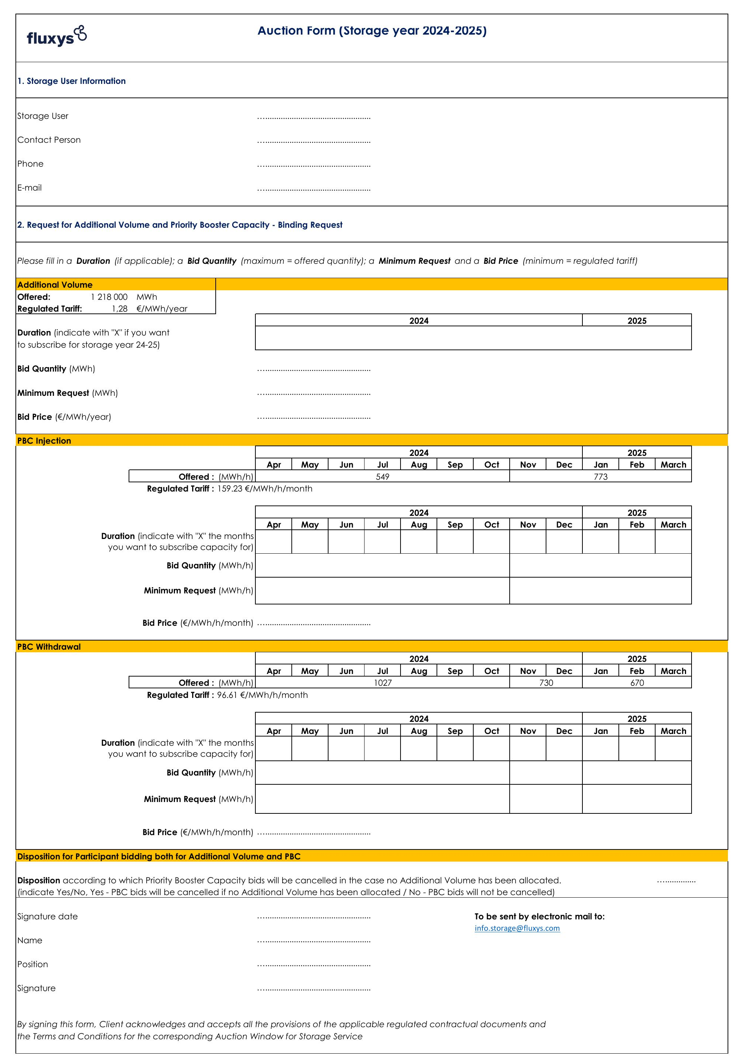

Period granularity for which Storage Services are offered: Storage Year for Additional Volume, month for Priority Booster Capacity
Storage Users for which the conditions for Financial Security as provided for in the SSA remain unchanged and for which the validity date of the existing Financial Security is still valid for the contracted Service Period do not have to adapt their Financial Security.

