Terms and conditions
  - SUBSCRIPTION WINDOW – Long term Storage Capacity

Table of Contents
1 Interpretation 2
2 Introduction 3
Scope 3
Description of the offered Services 3
Requesting the Services 4
Tariff(s) 5
3 Participating and submitting a Binding Request 6
Evaluation of the Binding Request 6
4 Allocation Process 7
Allocation Rules 7
Performance of the Services offered 7
5 Other provisions 8
Representations and Warranties by the Participant 8
Languages 8
Governing Law and disputes 8

Interpretation
In this Terms and Conditions for the Subscription Window (“TCSW”):
- All references to a clause/section/paragraph, unless specified otherwise, are references to a clause/section/paragraph in this TCSW;
- All capitalized words and expressions used in this TCSW are to be interpreted according to the list of definitions of attachment 3 of the Standard Storage Agreement (“SSA”), unless specifically defined in this TCSW;
- The layout, heading and (sub)sections are only for the benefit of the reader and are inconsequential as regards the interpretation of content of this TCSW;
- The description of rules, conditions and provisions only relates to the Storage Services offered via this TCSW;
- All dates and time are referred to as in Belgium local time.

Introduction

Scope
This TCSW defines the relation between the Storage Operator and the Participant to the Subscription Window and the requirements for participating to the Subscription Window.
The object of this Subscription Window concerns Storage Services starting on 01 April 2024 according to the provisions in the Access Code for Storage (“ACS”).
This Subscription Window will start at the opening time of 11 October 2023 at 09h00 local time (“Opening time”) and comes to an end on the closing time of 07 November 2023 at 15h00 (“Closing time”).
All requests received from Participants are binding (hereafter referred to as “Binding Requests”). Any Binding Requests received by the Storage Operator after the above-mentioned Closing Date shall automatically be excluded from this Subscription Window.
The Storage Operator will allocate the Storage Services through this Subscription Window at the latest on 08 November 2023 at 15h00.

Description of the offered Services
The offered Services via this Subscription Window (the “Offer(s)”) are:
- Long term Golden SBUs (SBUs) (starting at 01/04/2024)
  - Minimum duration: 2 Storage Years
  - Maximum duration: 10 Storage Years

- Priority Booster Capacity (PBC) (can only be booked for periods where Storage User has firm injection/withdrawal rights or SBUs)
  - Seasonal
  - Quarterly

Taking into account the Storage Services which have been previously subscribed, without prejudice to the provisions described in Attachment C2 of the ACS, the maximum amounts of capacity a Storage User can request for this Subscription Window are:
Storage Year | Offered Golden SBUs (firm)  # SBU’s | Offered PBC Injection  MWh/h | Offered PBC Withdrawal  MWh/h
2024-2025 | 89.136 | 773 | 1.027
2025-2026 | 96.272 | 807 | 1.072
2026-2027 | 96.272 | 807 | 1.072
2027-2028 | 250.000 | 1.700 | 2.260
2028-2029 | 250.000 | 1.700 | 2.260
2029-2030 | 250.000 | 1.700 | 2.260
2030-2031 | 250.000 | 1.700 | 2.260
2031-2032 | 250.000 | 1.700 | 2.260
2032-2033 | 250.000 | 1.700 | 2.260
2033-2034 | 250.000 | 1.700 | 2.260

Representing the following capacities per Golden SBU:
- Storage Volume | 30,44 | MWh
- Injection | 0,0113 | MWh/h
- Withdrawal | 0,0224 | MWh/h

Requesting the Services
The SBUs shall be requested by stating the number of requested SBUs, the number of requested Storage Years and the Service Start Date in the Binding Request by means of the Storage Request Form for Contracting (see SRFC in schedule 1 of this TCSW).
Secondly, according to paragraph 5 of this TCSW, Storage Users can also request Priority Booster Capacities. Please note that the available Priority Booster Capacities can only be booked during periods where the Storage Users has firm injection rights for PBC Injection and firm withdrawal rights for PBC Withdrawal. Furthermore, the allocation of PBC injection capacity (resp. PBC Withdrawal capacity) for a specific Storage Year can never be higher than the total offered PBC injection capacity (resp. PBC Withdrawal capacity) for this Storage Year times the ratio of allocated SBUs for this Storage Year to the total amount of offered SBUs for this Storage Year.
For specific conditions applicable to the Offers as described above we refer to the Access Code for Storage.

Tariff(s)
The applicable tariffs to the Services offered through this Subscription Window are the Regulated Tariffs. The Regulated Tariffs for 2024 still need to be approved by CREG but Fluxys Belgium proposes a 10% reduction compared to the consulted tariffs 2024-2027. Below the new proposed tariffs can be found:

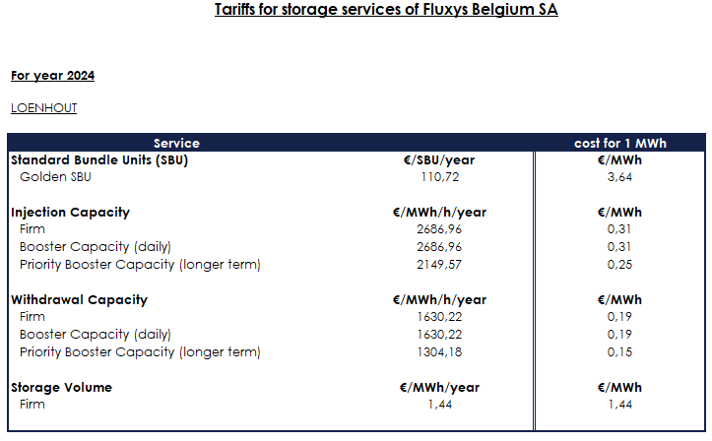

Please note that Energy in Cash will apply from 1 April 2024 (subject to CREG validation). For more information, please see consultation 65.

Participating and submitting a Binding Request
For the avoidance of doubt, pursuant to the Code of Conduct, before becoming a Participant a party has to be a Storage User by signing the SSA. By submitting to Storage Operator a duly completed and signed Binding Request, by means of the Service Request Form for Contracting (SRFC) attached in schedule 1 to this Subscription Window, Storage User becomes a Participant.

No later than the Closing time of this Subscription Window, the SRFC Request or other information or notices shall be sent to the Storage Operator by electronic mail to:

E-mail: info.storage@fluxys.com
Any notice pursuant to this article, shall be deemed effective (within Opening Time and the Closing Time) on the date/time that such e-mail is delivered to recipient.

Evaluation of the Binding Request
The Storage Operator shall evaluate if the SRFC of the Participant is in accordance with the rules as set out in this TCSW. Storage Operator has the right to require an adapted SRFC from the Participant, replacing the previous SRFC in case of missing information.
The Storage Operator shall in no way be liable for any damages of whatsoever nature in the event the Storage Operator does not accept the SRFC of the Storage User as a result of an incomplete SRFC.

Allocation Process

Allocation Rules
The available Services under this Subscription Window shall be allocated between the Participants in following order:
- First the SBUs will be allocated pro rata the requested amount of SBUs with priority to the longest consecutive duration on the period running from Storage Year 2024-2025 to Storage Year 2033-2024, taking into account previously booked SBUs, as described in section 2.2 attachment C2 of the ACS;
Secondly, the Priority Booster Capacity will be allocated per Storage Year with a cap equal to the total offered PBC Injection capacity (resp. PBC Withdrawal capacity) for this Storage Year times the ratio of allocated SBUs for this Storage Year to the total amount of offered SBUs for this Storage Year.
Please be reminded that any unreasonable request in order to exploit or misuse the allocation process can result in refusal of allocation (after consolidating with regulator).
The Storage Operator reserves the right to limit or annul the allocation of the capacities from this Subscription Window.
Storage Operator will inform the Participants about the allocation results no later than 08 November 2023 15h00 local time.

Performance of the Services offered
The submission of a Binding Request (by means of an SRFC) constitutes a legally binding offer on the part of the Participant which, for the Services allocated to the Storage User pursuant to and in accordance with the TCSW, shall be a legally binding commitment on Participants’ part, governed by the main conditions for Storage (SSA and the ACS).
Storage Operator shall only be considered to perform the Storage Services if Storage Operator has executed the necessary Service Confirmation Form for Contracting (as defined in the SSA).

Other provisions

Representations and Warranties by the Participant
In addition to article 9 of attachment 2 of the Standard Storage Agreement, the Participant warrants and represents:

- It determines independently its participation in the Subscription Window, without any contact with a competitor as to the frequency and the level of its SRFC.
- The Participant is aware of the obligations set by article 101 of the Treaty on the functioning of the European Union, article 2 of the Belgian loi sur la protection de la concurrence économique / Wet tot bescherming van de economische mededinging;
- It has not already sold, even on a conditional basis, the capacity which is being awarded through the Subscription Window; and
- The Participant will only submit a SRFC for capacity pursuant to a bona fide estimate of Participant’s actual needs. The Participant will not engage in hoarding behavior.

Languages
All communications pertaining to the Subscription Window shall be in the English language only. The convention used for writing numbers in this TCSW is that the point is used to indicate multiples of a thousand and the comma as the decimal point.

Governing Law and disputes
For the avoidance of doubt, articles 20 and 21 of the SSA are applicable.

Schedule 1:

SRFC for offered Storage Services requested by Storage User:

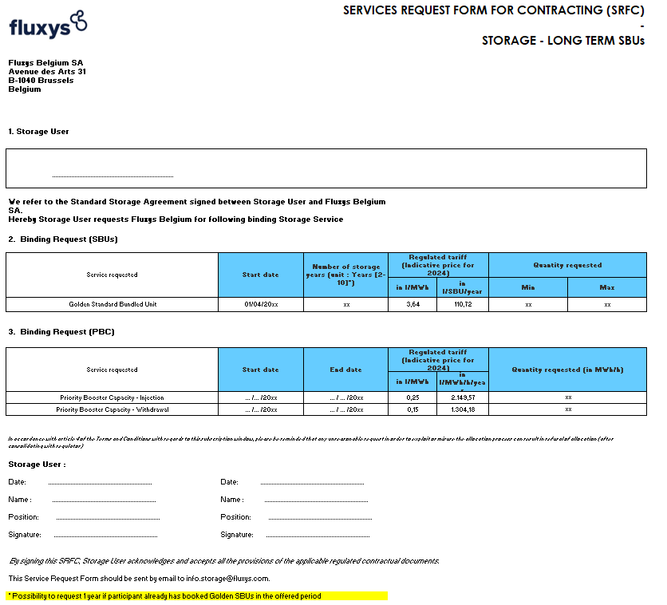

Taking into account previously booked SBUs and SBUs requested during this Subscription Window. For example, if Participant already booked SBUs for Storage Year 2024-2025, it is sufficient for him to request SBUs for 1 other Storage Year under this Subscription Window. If Participant has no SBU booked yet for the offered period, he needs to request SBUs for at least 2 Storage Years.

