New Operational Measures to support the Swiss Security of Supply: description

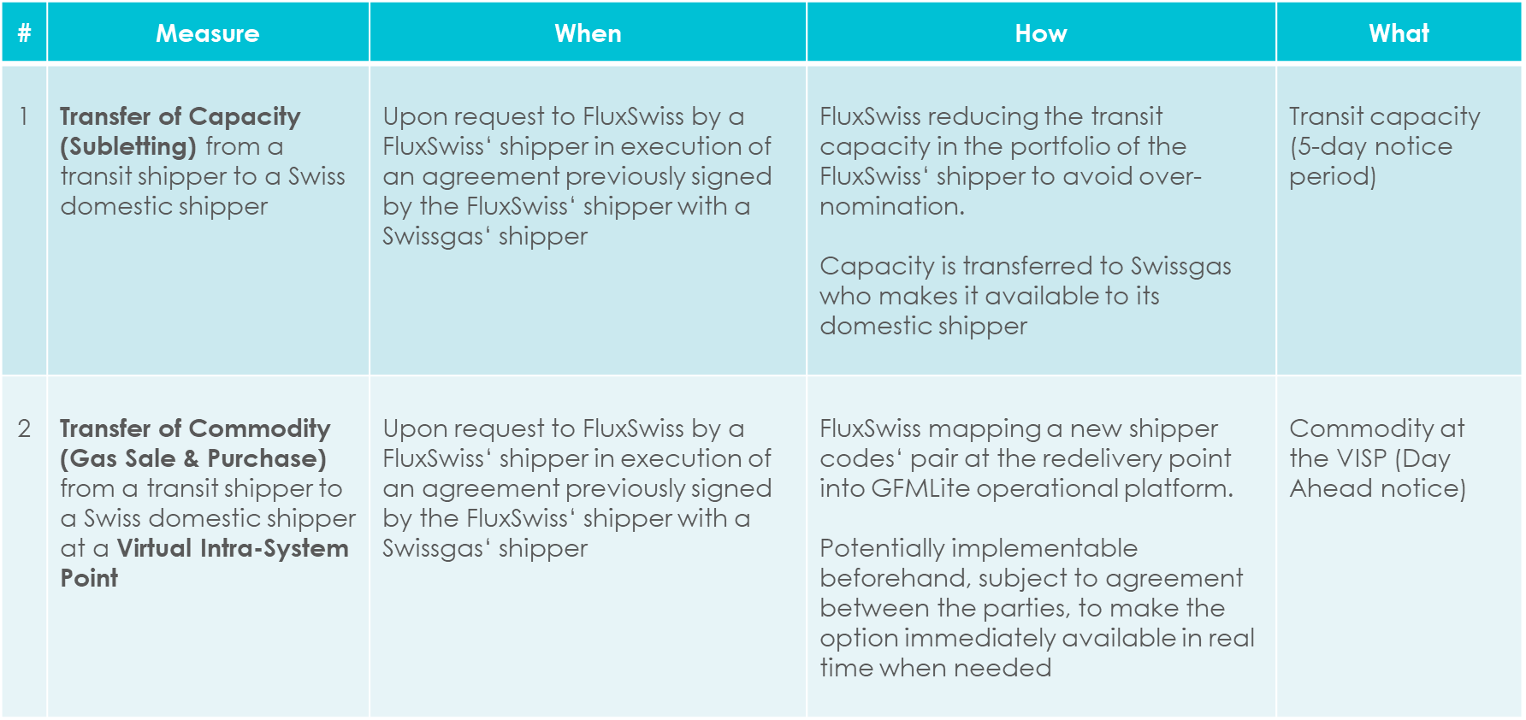

Capacity Transfer without nomination attached (valid until 30th September 2023)
- A Domestic Shipper with capacity on the Swissgas grid negotiates and agrees with a Transit Shipper holding capacity on the FluxSwiss grid the transfer of a given capacity for the purpose of using it to supply the Swiss domestic market during emergency.

- Transit Shipper emails FluxSwiss (operations@fluxswiss.com and dispatching.fluxswiss@fluxys.com) Cc’ing Swissgas (martena@swissgas.ch, grossen@swissgas.ch) as well as Domestic Shipper (relevant mailbox/contact person) by 15:00 of D-6 calendar days before the start date D of the transfer, notifying the validity period and the contact details of Domestic Shipper (company name, 24h phone number, email address).

- Domestic Shipper and Swissgas approve Transit Shipper’s request by replying to all by 16:00 D-6.

- By 17:00 D-6 calendar days, FluxSwiss confirms to Transit Shipper, Domestic Shipper and Swissgas the implemented reduction of Transit Shippers’ capacity in FluxSwiss systems. To keep track of the transfer, FluxSwiss inserts the relevant capacity in a dummy contract in the name of Domestic Shipper. As Domestic Shipper will not be provided with any user accounts to operate on FluxSwiss systems, the transferred capacity cannot be nominated.

- For the agreed validity period of the capacity transfer, Swissgas is entitled to make available the transferred capacity to Domestic Shipper according to its own regular procedures, thus temporarily exceeding its Transportation Capacity quota on the Transitgas pipeline as per the existing inter-TSO commercial agreements.
Gas Transfer at the Virtual Intra-System Point (valid until 30th September 2023)
- A Domestic Shipper with capacity on the Swissgas grid negotiates and agrees with a Transit Shipper holding capacity on the FluxSwiss grid the purchase of a given amount of gas with delivery at the Swiss Virtual Intra-System Point (VISP) for the purpose of supplying the Swiss domestic market during emergency.

- Transit Shipper emails FluxSwiss (operations@fluxswiss.com and dispatching.fluxswiss@fluxys.com) Cc’ing Swissgas (martena@swissgas.ch, grossen@swissgas.ch) as well as Domestic Shipper (relevant mailbox/contact person) by 15:00 of D-1 for D or following gas days, notifying the validity period and the new requested pairing (e.g., EH* <> 12Y*).

- Domestic Shipper and Swissgas approve Transit Shipper’s request by replying to all by 16:00 D-1.

- By 17:00 D-1 FluxSwiss confirms to Transit Shipper, Domestic Shipper and Swissgas the new implemented shipper codes‘ pair in FluxSwiss systems as from D.

- Provided nominations by Transit Shipper are balanced and submitted in due time, FluxSwiss will match them, and the nominated gas will be exchanged between Transit Shipper and Domestic Shipper at the VISP.

For further assistance:
operations@fluxswiss.com

Lorenzo Dondi
Operations Manager
+41 79 514 28 22

FluxSwiss 24/7 dispatching (c/o GMSL)
dispatching.fluxswiss@fluxys.com
+44 845 164 5079

